
West DC: Risk Assessment

Cycling Time Trials – West DC Course Risk Assessment Document. The measures to reduce risk identified in the right hand column must be included on the start sheet or implemented for the duration of the event as applicable. Failure to comply with the requirements of this document may result in approval being withheld with respect to subsequent race promotions by the

Course/Road(s) Assessed:  Somerford to Malmesbury, B4042 Brinkworth, B4696 Ballards Ash, B4040 Malmesbury, A429 Malmesbury, B4042 Somerford | Course:  U86/25  Distance (in miles):  25
Date of Assessment/Review:  23 March 202 – update to new format | Name of Assessor:  Paul Winchcombe
Review History:  First Produced (if known): 22 Feb 2014 earliest held  Last Review:  26 Jan 2024 – include new traffic count  21 November 2022, including adding street view | Sponsoring Club or Organisation:  Chippenham & District Wheelers
Course Description:
Start in Bus Stop area on The Hill, Little Somerford (OS ST 96663 84915) south of B4042

Turn left onto B4042 proceed west toward Malmesbury RAB with A429. Circle RAB and come back east on B4042 towards Brinkworth. Through Brinkworth to Ballards Ash junction with B4696. Turn left to Purton Road X-roads. Turn left to Baydon Manor and Minety. At X-roads on B4040 turn left to Malmesbury Watertower RAB. Turn left at RAB south on A429 towards RAB with A429/B4042. Turn left at RAB back onto B4042 east towards Brinkworth to finish eastern end of layby opposite Clay Street/B4042 Junction by Lovett Farm. (OS ST 97518 85053
Link:
https://www.strava.com/activities/5382471988/overview

Course Type:
- Single Carriageway
- Circuit
- No identified traffic calming measures or 20mph restrictions
Traffic Flows:
Traffic flows are generally low. Course should not be used during WOMAD
Course / Event History:
Course has been in used since 2014 and forms part of the U871, U86/50 and U86/100 courses which have been in use since at least 2010. There have been no significant incidents during this time.
Police Authorities:
Wiltshire Constabulary - Mr Bob Eccleston. Bob.Eccleston@wiltshire.police.uk

Risks Identified
No. | Distance / Location | Risk/Hazard | Level of Risk  (L / M / H) | Measures to reduce Risk  (if applicable)
a) Introduction
1 | General Requirements | Time of Road Usage meets CTT Traffic Standards | L | Traffic counts within acceptable numbers
b) HQ to Start
2 | Before Start | Competitors riding from Event HQ; Competitors warming up | L | Instructions on Start Sheet and at event HQ signing on advising riders of safe routes ; prohibition on warming up past the start
3 | Area of Start:  Start in Bus Stop area on The Hill, Little Somerford (OS ST 96663 84915) south of B4042 | Competitors wait on road in single file | L | Instructions on Start Sheet and at event HQ signing on - warning against making ‘U’ turns, queue in single file ; Cycle Event Warning signs
 |  | 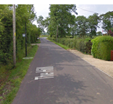 |  | Start scariest.jigging.forgiven
c) Start to Finish
4 | North West towards B4042 | Turn left onto B4042 proceed west toward Malmesbury RAB with A429. | M | Observer optional; Direction sign; 2 x Cycle Event warning signs on main road (if no observer)
 |  | 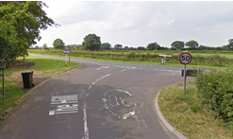 |  | Riders turn left onto main road - give way to traffic from the right
5 | Priory Roundabout (Malmesbury): Junction A429 / B4042 | Circle RAB and come back east on B4042 towards Brinkworth and Wotton Bassett.  Riders turn (4th exit) and retrace on B4042; traffic on RaB from A429. | M | Observer (optional and is a large RAB with good lines of sight); Direction sign; Cycle Event warning signs on all approaches  Warning on start sheet as descent to RaB is fast.
 |  | 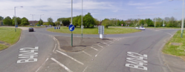
6 | Descent to River Avon after RAB | Descent from top of hill towards River Avon and is fast. Drivers may hold up riders, especially if turning, riders are not to overtake cars on the descent | L | Warning on start sheet to observe Highway Code
7 | Follow to Ballards Ash junction | Turn left onto B4696 | L | Place 1 x observer wearing high visibility vest. (not mandatory). Riders have priority.  Cycle event warning signs, direction arrows
 |  | 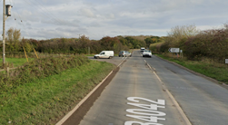
8 | Purton Road X-roads | Turn left onto unclassified road towards Baydon House and Minety | L | Nil. Visibility is good and riders have priority, wide junction.  Cycle event warning signs  Direction signs needed
 |  | 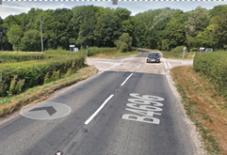 |  | Drain and 3 x hydrant covers on riders line
9 | Road turns North (right) after 0.65 mile while road appears to go straight on (which is actually turn onto another unclassified road) | No hazard | Nil | Direction Signs needed
10 | X-road unclassified road The Common / Station Road / Silver St / /Malmesbury Road (B4040) | Turn left onto B4040 towards Malmesbury.  Traffic from right has priority. | M | Place 1 x observer wearing high visibility vest (optional).  Use 2 x Cycle Event warning signs on main road (if no observer) and 1 x Cycle Event warning signs on all approaches  Direction signs
 |  | 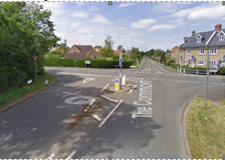 |  | Riders turn left onto B4040 - give way to traffic on right; limited visibility
11 | Note: Narrow bridge on bend ½ mile before RAB | Oncoming traffic may not give way | M | Cycle Event Warning signs  Riders to be warned at HQ
12 | Follow to Malmesbury water tower (Crudwell) Roundabout: Junction B4040 / A429 | Turn left onto A429 at RAB heading South towards Southern Malmesbury RAB. Traffic from right has priority | L | Place 1 x observer wearing high visibility vest (not mandatory).  Visibility is good and junction is wide  Direction sign; Cycle Event warning signs on all approaches
 | Riders take first left exit to join A429 | 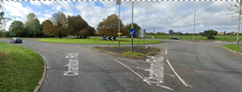
13 | 200 yds before RAB | Traffic Island in middle of Road for Waitrose | L | Notice at HQ Signing On
14 | Priory Roundabout (Malmesbury): Junction A429 / B4042 | Turn left onto B4042 at RAB.  Towards Brinkworth | L | Place 1 x observer wearing high visibility vest (not mandatory). Visibility is good and junction is wide  Direction arrow; Warning signs
 | Riders take first left exit to join B4042 | 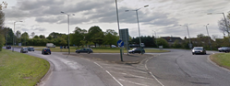
15 | Descent to River Avon after RAB | Descent from top of hill towards River Avon and is fast. Drivers may hold up riders, especially if turning, riders are not to overtake cars on the descent | L | Warning on start sheet to observe Highway Code  (As per Serial 6)
16 | Finish: Beyond Eastern end of layby opposite Clay Street/B4042 Junction by Lovett Farm. (OS ST 973850) 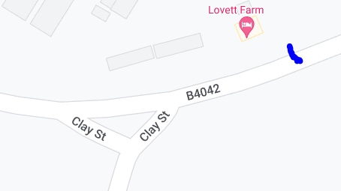 | Awareness of surroundings | L | No u-turns.  Note on start sheet to be aware of surroundings and other road users at the finish.
 |  | 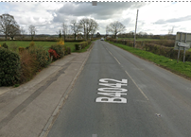 |  | Finish  ST 97518 85053  remission.lakes.bedrooms
17 | After finish | Competitors returning to event HQ. | L | Instructions on safe route back from finish to HQ.

After finish continue turn with care and take Clay Street back to Little Somerford.

https://ridewithgps.com/routes/20370301
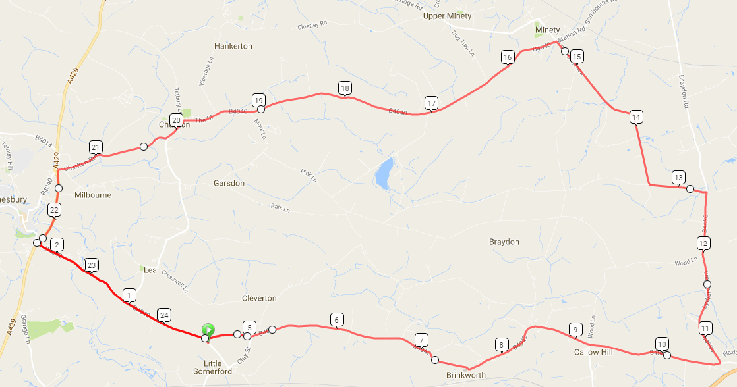

Important Notes
1. The course is generally expected to be quiet during the event
2. There are two sharp corners:
• In Charlton: This corner is blind to oncoming traffic, so take care
• Between Charlton and A429, crossing river bridge: This corner has good visibility, however unless you brake early you will cross the white central line, so look out very carefully for oncoming traffic.
4. There are 2 sharp turns at Baydon turn (12.5 miles) and Minety turn (15.3 miles).
5. The descent to the Avon River after the southern Malmesbury RAB is a 30 mph zone. Be aware that drivers may slow to turn into the houses on the left. Care and observance of the Highway Code is required.
6. The onus is on the rider to know the course but all turns will be signed. There will be some officials on course doing traffic counts and ensuring course compliance.

Notes
- The small junctions or entrances to farms/ facilities (garage,.eatery, etc) that are not identified in this risk assessment have been considered, however are not considered significant to pose a risk and therefore have not been noted.
- The course should not be used on public bank holiday weekends or when there are major local events. E.g. Womad, Badminton, Polo Competition, Air Show, etc
- Riders would prefer it if observers on the left turn from the B4042 onto the B4696, at left onto B4040 at Minety, however these are not obligatory from a Risk Assessment point of view if double signage is used

This document remains live and any changes to the items listed above or new hazards/risk that arise should be notified to the district committee at the earliest opportunity.

CYCLING TIME TRIALS IS A COMPANY LIMITED BY GUARANTEE REGISTERED IN ENGLAND No: 4413282
Registered Address: 77 ARLINGTON DRIVE, PENNINGTON, LEIGH, LANCASHIRE. WN7 3QP November 2003

