Risk Assessment proforma*

Course | K47/15 | 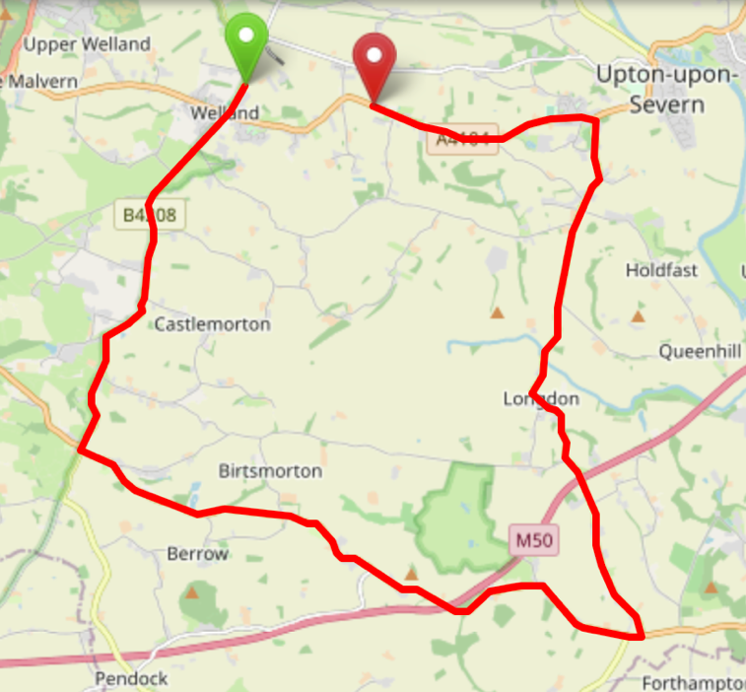
Area | Midland DC
Description | Welland – Castlemorton – Long Green –  Tunnel Hill - Welland
HQ | Welland
Measured | 01/10/2023
Measured by | D Grant
Risk assessed | 01/10/2023
Assessed by | DC Risk Assessor
Date approved | 01/10/2023
Type A | Approved for Type A & Type B
Type B
Police Authority
Additional information
Notes for riders
OS Grid # | Course description | Distance | Risk (L/M/H) | Risk description | Minimum management  (Without prejudice)
SO 7989 4037 | Start on the B4208 at farm entrance junction (approximately a quarter mile north of the main staggered crossroads in Welland) | 0 | M | Riders and officials on or near the highway  Riders congregating at the start | Cycle event in progress signs.  Officials on or near road to wear high viz jackets.  Riders not yet started to wait off the carriageway.
SO 7777 3569 | At Rye Cross junction turn left onto the A438 | 3.4 | L | Left turn onto side road | Cycle event in progress signs on all approaches to the crossroads
SO 8495 3329 | At Long Green junction with the B4211, filter left onto the B4211 | 8.55 | L | Left turn via filter lane onto B4211, give way junction at the end of filter lane | Cycle event in progress signs on all approaches to the junction  Riders to Give Way
SO 8442 3994 | At Tunnel Hill junction turn left on the A4104 | 13.14 | L | Left turn, Give Way junction | Cycle event in progress signs on all approaches to the junction  Marshal on Junction  Riders to Give Way
SO 8154 4011 | Finish at | 15 | L | Riders and officials on or near the highway | Finish sign at approach to finish and finish board by timekeeper.  Officials on or near road to wear high viz jackets.  Finished riders to return to HQ

References:

CTT GN22 – Risk Assessment

Date of Issue | Reason of Revision | Author
March 2013 | New edition | David Barry  (CTT Board Director)  (CTT Course Risk Assessor)
August 2018 | Revised format | Nick Sharpe  (CTT National Secretary)
October 2022 | Revised to reflect current CTT Articles, Rules, and Regulations | David Barry  (CTT Board Director)

