
West DC: Risk Assessment

Cycling Time Trials – West DC Course Risk Assessment Document. The measures to reduce risk identified in the right hand column must be included on the start sheet or implemented for the duration of the event as applicable. Failure to comply with the requirements of this document may result in approval being withheld with respect to subsequent race promotions by the promoting club.
(CTT Guidance Note 22 – Appendix 2 – Issue 2 September 2011 provides additional advice)
Course/Road(s) Assessed:  Lampern Road, Uley | Course: UH15  Distance (in miles): 1 Mile
Date of Assessment/Review:  26 August 2023 | Name of Assessor:  Paul Winchcombe
Course Description:
Course climbs Lampern Hill which is last hill of U14B3
https://www.cyclingtimetrials.org.uk/course-details/uh15

Traffic Flows:
Generally quiet, unclassified road
Course / Event History:
Course used by Dursley Road Club
Key Identified Risks
No. | Distance / Location | Risk/Hazard | Level of Risk  (L / M / H) | Measures to reduce Risk  (if applicable)
a) Introduction
1 |  | General requirements | L | Time of road usage meets CTT Traffic Standards.  Traffic counts within acceptable numbers.
b) Start area
2 | Area of start | Competitors:  - Warming up  - Waiting to start | L | Competitors instructed not to make “U” turns within sight of the start and to avoid warming up on the course, once the event is underway.  Competitors instructed to keep off the carriageway whilst waiting to start.
 | Start in area of ///bowls.wedding.embellish | 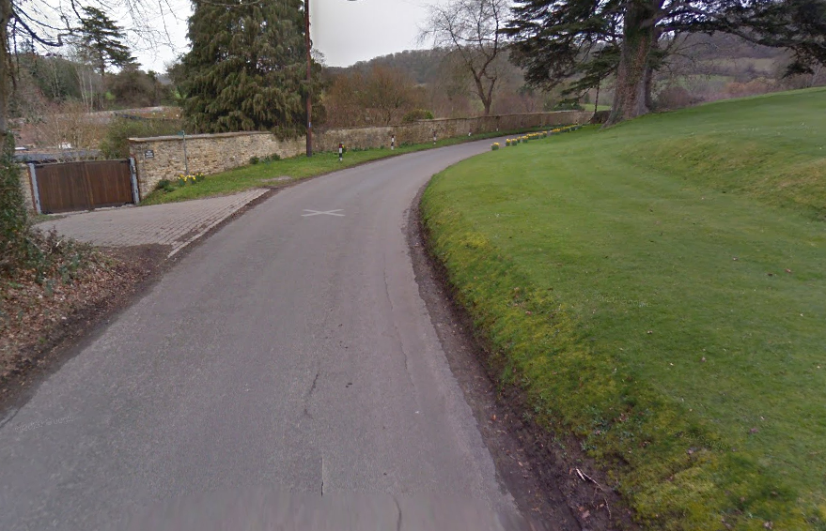
 | There are only 2 junctions on the course, both to private driveways | One on right  One on left | L
 | Finish in area of ///jolt.mushroom.repay | 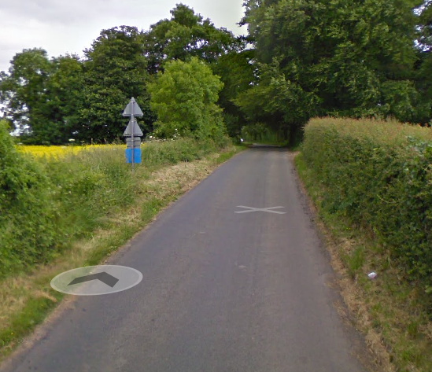
c) Finish
3 | Finish | Competitors:  - Performing U turns after the finish  - Returning to speak to the timekeeper  - Stopping in road to recover | L | Competitors instructed not to undertake either action but to return directly to Event HQ after finishing the event  Competitors asked to pull into the unclassified road at the top of the climb if they need to catch their breath.

Notes
- The small junctions or entrances to farms/ facilities (garage,.eatery, etc) that are not identified in this risk assessment have been considered, however are not considered significant to pose a risk and therefore have not been noted.

