
West DC: Risk Assessment

Cycling Time Trials – West DC Course Risk Assessment Document. The measures to reduce risk identified in the right hand column must be included on the start sheet or implemented for the duration of the event as applicable. Failure to comply with the requirements of this document may result in approval being withheld with respect to subsequent race promotions by the promoting club.
(CTT Guidance Note 22 – Appendix 2 – Issue 2 September 2011 provides additional advice)
Course/Road(s) Assessed:  Cricklade - A419 – Airfield RAB – A419 | Course:  U47R  Distance (in miles):  10 Miles
Date of Assessment/Review:  7 May 2023 | Name of Assessor:  David Wright  Updated by Paul Winchcombe with Google Images – 7 May 2023 (hyperlinked)
Review History:  First Produced (if known): 2020 recommissioned  Last Review: 30 July 2022 (new format) | Sponsoring Club or Organisation:  Tetbury Velos
Course Description:
Start at end of bus stop layby by Cricklade RFC gate on B4040 west of A419.
Take first exit on RaB signed Cirencester; join the A419.
Take sliproad to Airfield RaB, signed Cirencester Industrial Area / Stroud, A419.
Turn right at RaB, 3rd exit, to rejoin A419 eastbound Swindon / Cricklade.
Leave dual carriageway at Cricklade; first exit RAB (junction with B road), finish at lamp post 238 just past RaB.

Link:
https://www.cyclingtimetrials.org.uk/race-course/25580#anchor
Course Type:
- Dual Carriageway
- Out and Back
Traffic Flows:
Traffic flows are within limits but a count must be done at each event to confirm this remains so.
The course has been used late evening in the past but not recently, so a new evening traffic count would be needed if a club wished to run an evening event.
Course / Event History:
This course has been in use since at least 2013 and previous versions using the dual carriageway date to at least 2007. Use was suspended for several years after some traffic incidents where clubs did not wish to use the course. Course was recommissioned in 2020.

No events in poor visibility – see footnote.
No. | Distance / Location | Risk/Hazard | Level of Risk | Measures to reduce Risk
No. | Distance / Location | Risk/Hazard | (L / M / H) | (if applicable)
a) Introduction
1 | General Requirements | Time of Road Usage meets CTT Traffic Standards;  Weather conditions are acceptable – no excessive spray or fog. | L | Traffic counts within acceptable numbers; Take Traffic Counts during event;  Delay start or cancel event.
b) HQ to Start
2 | Before Start | Competitors riding from Event HQ; Competitors warming up | L | Instructions on Start Sheet advising riders of safe routes and alternative parking; prohibition on warming up past the start
3 | Area of Start – Bus Stop at outskirts of Cricklade | Congregation of competitors waiting, give a large moving target | M | Instructions on Start Sheet – warning against making ‘U’ turns; Cycle Event Warning sign;  Don't hold events when bus stop is in use
4 |  | 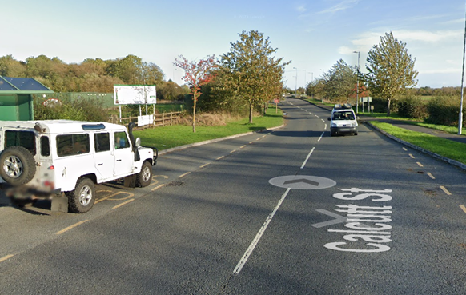
c) Start to Finish
5 | Bus Stop at Start on B4040 | Competitors starting pulling out into traffic | L | Use the course only when traffic counts acceptable.  Cycle event sign prior to bus stop
6 | RAB at end of Cricklade slip roads to DC | Traffic on RAB and competitors come together  Riders take first exit / left; give way to traffic from the right | L | Good sight lines, competitors take first exit.  Cycle event sign on slip road approach to RAB from A419.  Optional observer on RAB
7 | Riders take first exit | 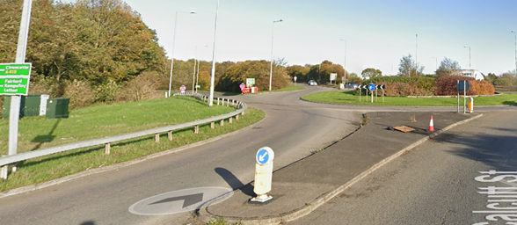
8 | Joining the A419 DC | Riders enter the DC, traffic on the DC | M | Large Cycle Event Warning sign on slip road
9 | Passing the North Cricklade junction | Traffic entering the DC, with riders on the DC | M | Warning sign prior “RAB” at the start of slip road to the DC
10 | Passing the North Cricklade junction | Traffic entering the DC, with riders on the DC | M | Warning sign on exit of “RAB” start of slip road to the DC
11 | Passing the Spine Road Junction | Traffic travelling north entering the DC, with riders on the DC | M | Warning sign at exit of Spine Road west RAB.
12 | Riders exit at the Cricklade Exit  Airfield junction | Riders Leave the DC  Riders take left filter road off A419 | L | Riders have right of way and stay left. Start sheet to make clear riders need to know the course in advance.
13 | Signposted Cirencester Industrial Area Stroud A419 | 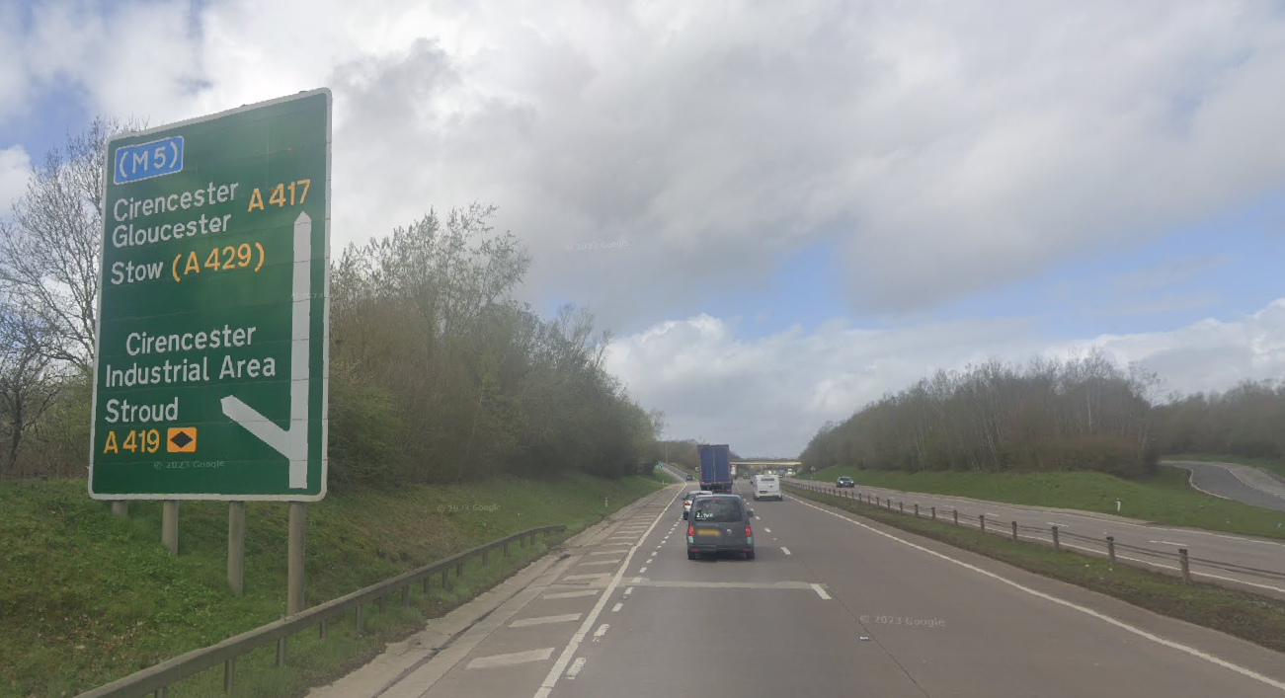
14 | Airfield RaB | Riders take 3rd exit back onto A419; give way to traffic on the RaB | M | Observer (optional but should do rider count) and Cycle Event Warning sign on RAB approach from Cirencester
15 | Riders take 3rd exit  Signposted Swindon A419 M4  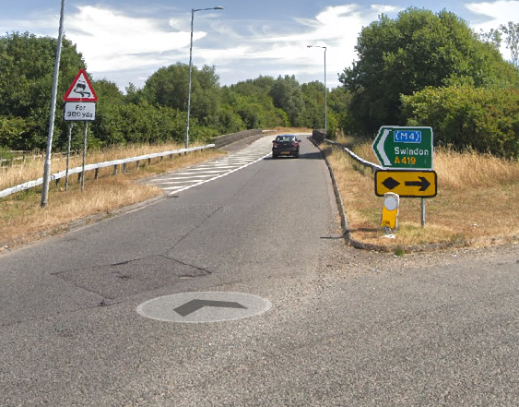 | 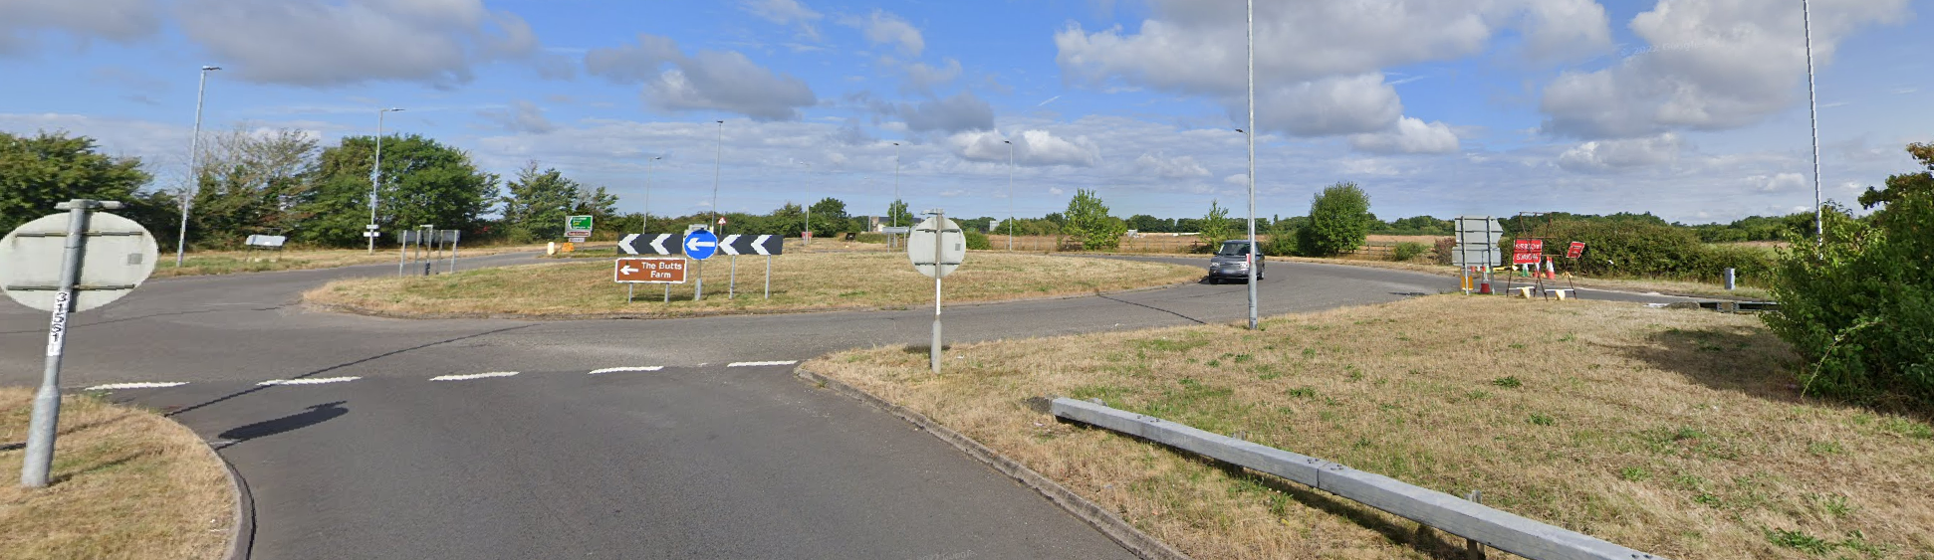
d) Turn to Finish
16 | Slip road onto A419 from Cirencester (north) | Riders join A419; Traffic on bypass from Cirencester joining course | M | Large Cycle Event Warning sign on slip road joining A419 eastbound
17 | Spine Road junction | Riders continue on A419; Traffic joining A419 | M | Cycle Event Warning sign at start of slip road joining A419 eastbound.
18 | Slip road onto A419 from Latton (south) | Riders continue on A419; Traffic joining A419 | M | Cycle Event Warning sign at start of slip road joining A419 eastbound
19 | Cricklade Junction | Riders take slip road off A419 | L | Direction sign at beginning of slip road
20 |  | 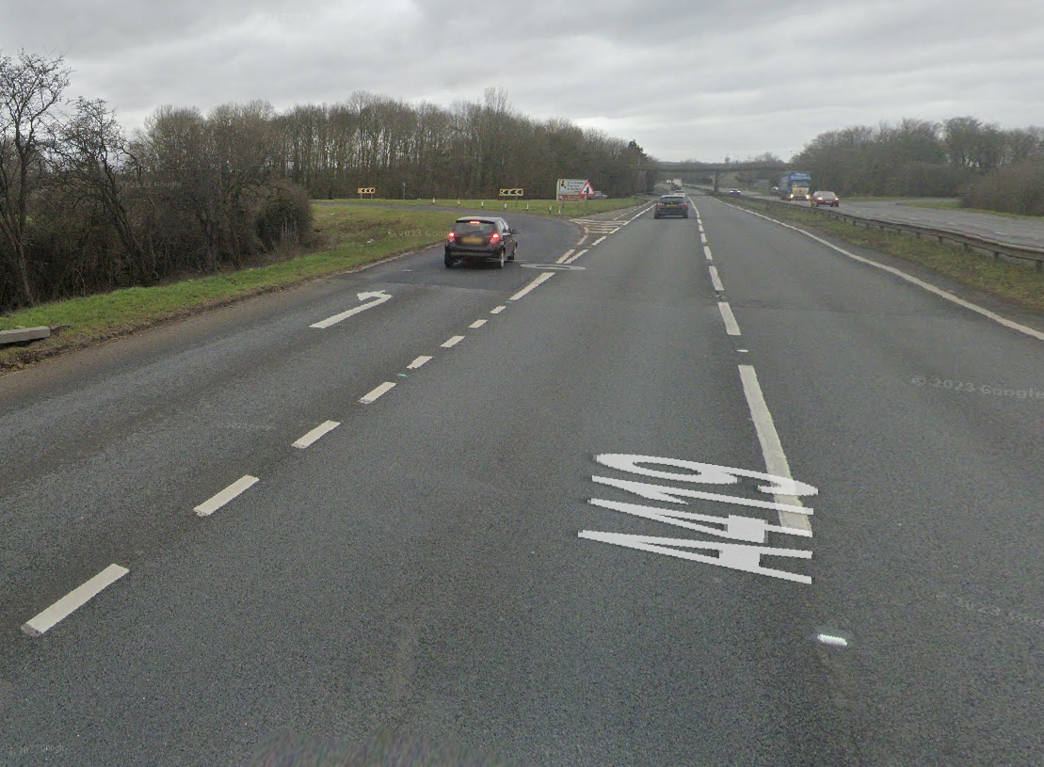
21 | Round-a-bout  RAB on A419 exit of the DC | Traffic on RAB  Riders take second exit; give way to traffic from the right  Do not turn into the closed exit | M | Observer (optional) on RAB and Cycle Event Warning sign on RAB approaches from Swindon and Cricklade
22
  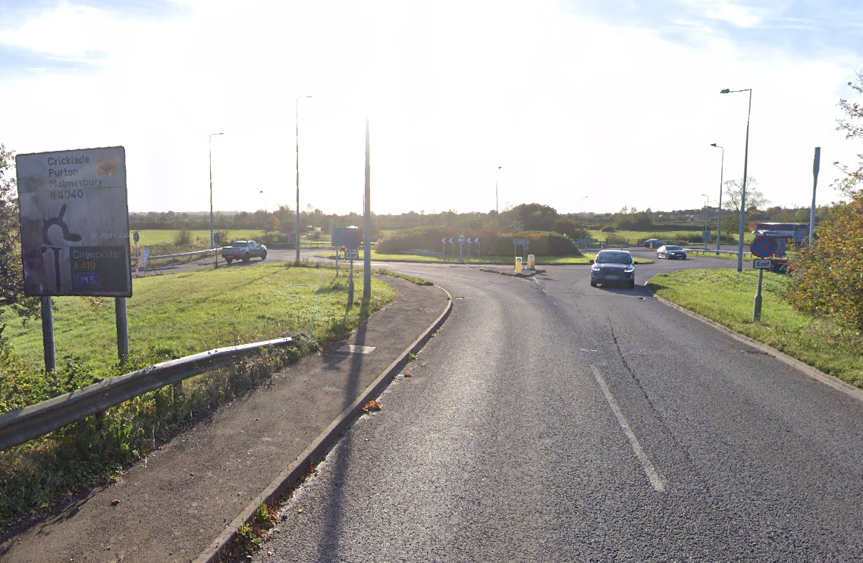
23 | Finish | Road Users | M | Warning on start sheet not to perform ‘U’ turns at the finish – continue on and return to the HQ. Also, a note to be aware of surroundings and other road users at the finish.
24 | After finish | Road Users | M | Instruction on start sheet to continue on to the next roundabout and make way back to the HQ.

Footnote: Include on start sheet:
Please note: A large part of this course is a dual carriageway and if the weather is poor the visibility deteriorates quickly. The event will be delayed or cancelled if there is a danger to riders.

Start Description
Start is in the bus stop of the North side of the road (for traffic eastward), bus stop between the two roundabouts to the east of Cricklade on the B4040, the exit roundabout for the A419 DC, and the next roundabout on the edge of Cricklade. The start is in line with the eastern edge of the drain cover in the middle of the bus stop, almost immediately opposite lamp post #32.

Finish Description
Finish after the slip road, on the Cricklade exit of the A419 DC travelling south. Cross the bridge and take second exit to Cricklade.
The finish is after Calcutt Street crosses the River Key by lamppost #238.
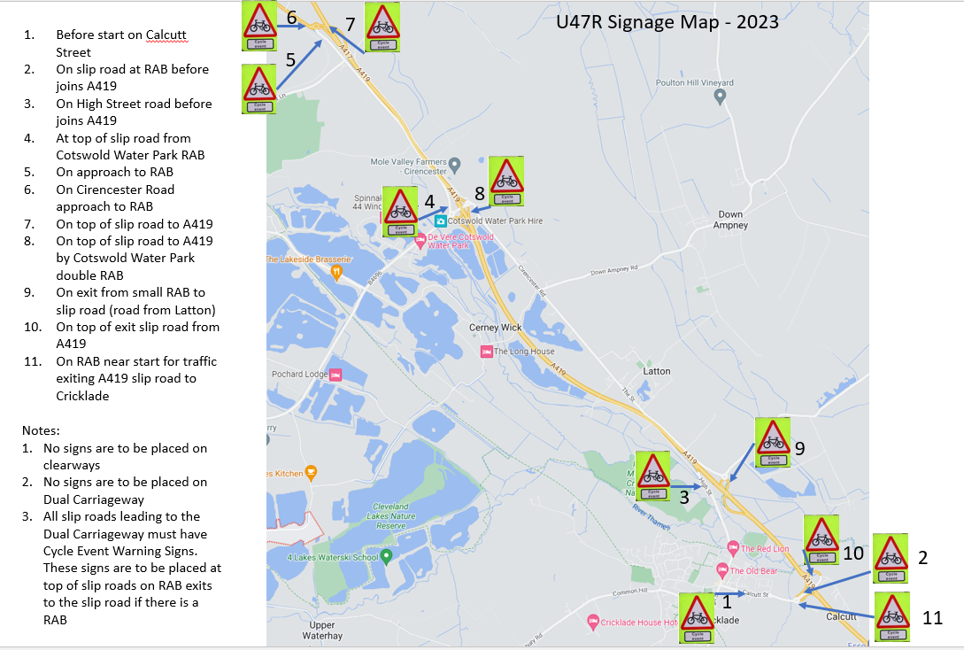
This document remains live and any changes to the items listed above or new hazards/risk that arise should be notified to the district committee at the earliest opportunity.
CYCLING TIME TRIALS IS A COMPANY LIMITED BY GUARANTEE REGISTERED IN ENGLAND No: 4413282
Registered Address: 77 ARLINGTON DRIVE, PENNINGTON, LEIGH, LANCASHIRE. WN7 3QP November 2003

