
West DC: Risk Assessment

Cycling Time Trials – West DC Course Risk Assessment Document. The measures to reduce risk identified in the right hand column must be included on the start sheet or implemented for the duration of the event as applicable. Failure to comply with the requirements of this document may result in approval being withheld with respect to subsequent race promotions by the promoting club.
(CTT Guidance Note 22 – Appendix 2 – Issue 2 September 2011 provides additional advice)

Course/Road(s) Assessed:  B4058, A4135, B4066 | Course:  U14B3  Distance (in miles):  28
Date of Assessment/Review:  Last review was in 2015. This review is an update based on Google Streetview and should be revalidated by 2023 organiser. | Name of Assessor:  Updated by Paul Winchcombe in February 2023
Course Description:
(This should allow major turns, start and finish to be identified. This may be the course description used in the Police Notification Form.) PNF course description is required.
Link:
https://www.strava.com/activities/51124256/

Traffic Flows:
New traffic count is required but historically has been low
Course / Event History:
Course was in use in 2013 to 2015. Is to be used again in 2023.

Key Identified Risks

No. | Distance / Location | Risk/Hazard | Level of Risk  (L / M / H) | Measures to reduce Risk  (if applicable)
a) Introduction
1 | General Requirements | Time of Road Usage meets CTT Traffic Standards | L | Traffic counts within acceptable numbers ; Take Traffic Counts during event
b) HQ to Start
2 | Before Start | Competitors riding from Event HQ; Competitors warming up | M | Instructions on Start Sheet and at event HQ signing on advising riders of safe routes ; prohibition on warming up past the start
3 | Area of Start | Competitors waiting | L | Instructions on Start Sheet and at event HQ signing on - warning against making ‘U’ turns ; Cycle Event warning sign
c) Junction of A4135 to Frocester Junction
 | Start: On B4058 Coombe Road  //vows.wept.boards | 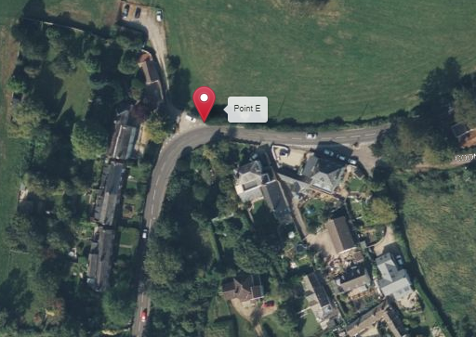 |  | TBC
4 | 2.8m junction with A4135 and lane on right | Left turn joining main road | M | Observer optional as good visibility/ Note junction is a give way.
 |  | 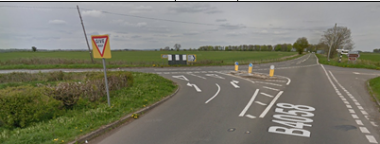
5 | 4.4m lane on left sp Stinchcombe Hill | Potential traffic | L | Note
6 | Dursley; minor roads left and right | Traffic | L | Start sheet note: care
7 | 5.4m Mini RAB in Dursley where turn right | Right turn at RAB | M | Sign; observer, start sheet note
 |  | 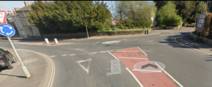
8 | 5.5m right turn at approach to estate | Right turn across very quiet road | M | Observer to stand at exit, start sheet note
 | Clear signage needed as junction has lot of traffic furniture | 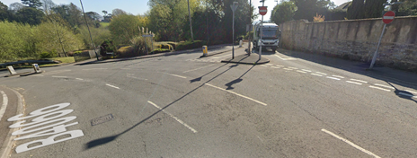
8 | 7.2m Road on left | Potential Traffic | L | Note
9 | 7.4m Road on left | Potential Traffic | L | Note
10 | 7.6m Traffic in Uley | Potential Traffic/pedestrians | L | Note
11 | 7.7m road on right | Potential Traffic | L | Note
d) Frocester/Eastington/Frocester
12 | 9.2m crossroads where turn left down Frocester Hill, | Left turn onto ‘slip’ road then minor road | M | Observer optional as turn should be clear with turn arrows, sign and start sheet note
 | Note after slip road the junction is a give way to the right. There is good visibility. | 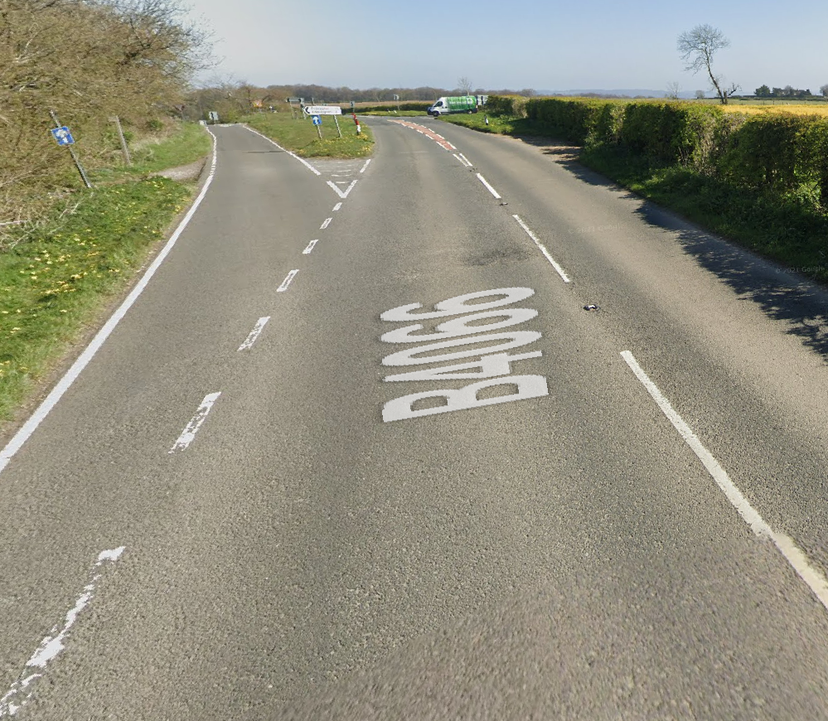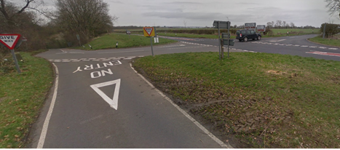
13 | 9.2m+ steep descent of Frocester Hill | Restricted road, sharp bends |  | Sign warning of steep descent, start sheet note
14 | 11.2m Frocester crossroads | Potential traffic | L | Note
15 | 12.3m | Traffic Calming Island | L | Left hand side; note on startsheet
16 | 12.7m RAB in Eastington, retrace to top of Frocester hill | Circle RAB, retrace | M | Start sheet note, Observer optional, good visbility
 |  | 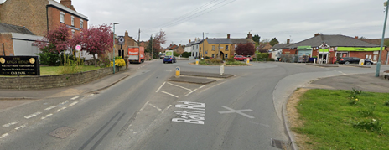
17 | 16.2m left to Stroud | Left onto main road B4066 (see ser 12) | M | Observer optional riders have good view to right and uphill approach, start sheet note
 |  | 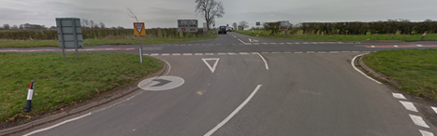
e) Frocester Hill To Selsey RAB, return and final climb up Stouts to finish
18 | 19m Descent to Selsey RAB | 2 cattle grids, steep descent, narrow passing width | M | Observer on descent,  observer at RAB (both optional) start sheet note
19 | 20.5m Retrace Selsey Hill to top of Frocester Hill, | Circle RAB, retrace | M | n/a
 | Descent approach to RaB is fast and may be queuing traffic | 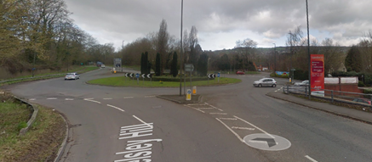
20 | 26m Continue down Crawley Hill to Uley | Traffic in Uley, fast descent | M | Observer near bottom of hill
21 | 27m Left up Lampern / Stouts Hill to finish by farm gate before junction at 28 miles | Sharp left turn | L | Observer on left turn
 |  | 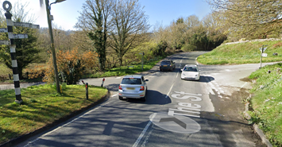
 | Area of finish (TBC)  // bossy.landscape.desk | 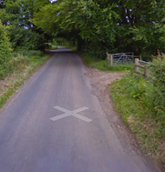

Notes
- The use of a vehicle for the timekeeper(s) at start and finish is where appropriate and is only identified as an example for the action to be taken
- The small junctions or entrances to farms/ facilities (garage,.eatery, etc) that are not identified in this risk assessment have been considered, however are not considered significant to pose a risk and therefore have not been noted.
- Riders must be warned that descents are fast and that approaches to RaBs (especially if queuing traffic) need care.
- Riders must be warned that there are cattle grids on descents.
- Riders must be warned that there is right turn across a road junction where there is a lot of road furniture.

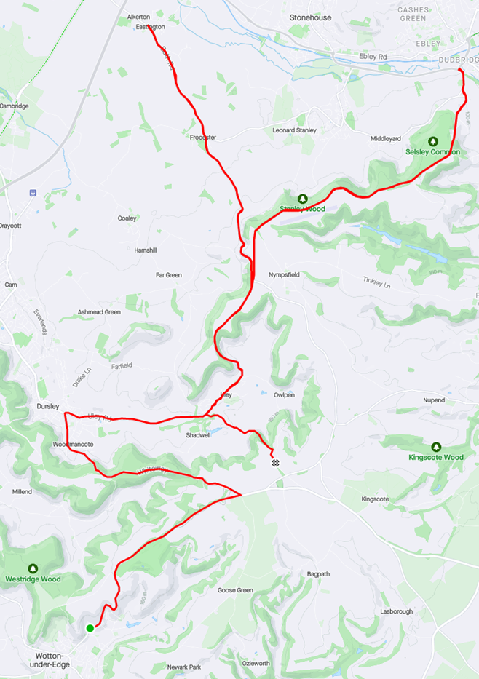

This document remains live and any changes to the items listed above or new hazards/risk that arise should be notified to the district committee at the earliest opportunity.

CYCLING TIME TRIALS IS A COMPANY LIMITED BY GUARANTEE REGISTERED IN ENGLAND No: 4413282
Registered Address: 77 ARINGTON DRIVE, PENNINGTON, LEIGH, LANCASHIRE. WN7 3QP November 2003

