
West DC: Risk Assessment

Cycling Time Trials – West DC Course Risk Assessment Document. The measures to reduce risk identified in the right hand column must be included on the start sheet or implemented for the duration of the event as applicable. Failure to comply with the requirements of this document may result in approval being withheld with respect to subsequent race promotions by the promoting club.
(CTT Guidance Note 22 – Appendix 2 – provides additional advice)

Course/Road(s) Assessed:  Minety to Malmesbury, B4042 Brinkworth, B4696 Ballards Ash, B4040 Malmesbury, A429 Malmesbury, B4042 Somerford | Course:  U86/100  Distance (in miles):  100
Date of Assessment/Review:  23 March 202 – update to new format | Name of Assessor:  Paul Winchcombe
Review History:  First Produced (if known): 2015 earliest held  Last Review:  6 June 2024 – include new traffic count | Sponsoring Club or Organisation:  Chippenham & District Wheelers
Course Description:
Start: Start is in the hard standing entrance to Ravenhurst farm, in line with the H 100/8. On the minor road south of Minety (south from Turnpike Inn).
Course: Leaving the start, progress north to Minety. On reaching the B4040 turn left onto the B4040. Proceed westward through Charlton and onto the RAB on the A429 just before Malmesbury. Left to turn south on the A429. Proceed to next RAB with the B4042, where left onto the B4042. Proceed eastward, passing through Brinkworth, and The Common till reaching the B4696 (just before the M4 motorway). Left onto the B4696 (sign posted Ashton Keynes, Cricklade, Cirencester). After approximatly 2 miles, take the left turn at Braydon Cross (sign posted Garsdon). Follow to top of minor climb, where follow the road through its right turn (signed Minety 1½). Follow through to pass the start. This forms the first loop.
The loop is performed five times. Each loop being 19.99miles.
On passing the start for the 5th time, the finish is just over the brow hill north of the start.
Finish: The finish is in line with the HP Gas Pole about 200m north of the start.

Link:
https://www.cyclingtimetrials.org.uk/course-details/u86-100

Course Type:
- Single Carriageway
- Circuit
- No identified traffic calming measures or 20mph restrictions
Traffic Flows:
Traffic flows are generally low. Course should not be used during WOMAD
Traffic counts have been below 400 and the main course is quiet with little traffic. There were some concerns that there would be a build up of traffic on the A429 after 10am when a supermarket opens up but this has not been reported to be the case. This section of road between the two Malmesbury RABs is where traffic counts will be focused.
Course/Event History:
This was a new course in 2015. It is based on the U86 25m course, first used in 2014, which in turn was based on the WTTA hardrider course U871 (previously the U87). It is also the course used for U86/50 used from 2015. So the roads have been in use for timetrials over a long period, no serious issues have happened in the past.
Risk Assessment has been updated to reflect last running of U86/25 which uses same course.
Police Authorities:
Wiltshire Constabulary - Mr Bob Eccleston. Bob.Eccleston@wiltshire.police.uk

Key Identified Risks

Distance | Location | Identified Significant Risk/Hazards | Level of Risk  Low/Med/High | Measures to reduce Risk  (if applicable)
a) Introduction
 | General Requirements | Time of Road Usage meets CTT Traffic Standards | L | Traffic counts within acceptable numbers
b) HQ to Start
 | Before Start | Competitors riding from Event HQ; Competitors warming up | L | Instructions on Start Sheet and at event HQ signing on advising riders of safe routes ; prohibition on warming up past the start
0 miles | Area of Start: Ravenhurst farm hard standing | Riders waiting for start interfere with flow of traffic. Unlikely to be an issue at time of start and area to wait in | L | Cycle Event Warning Sign on the minor road south of the start.
 |  | 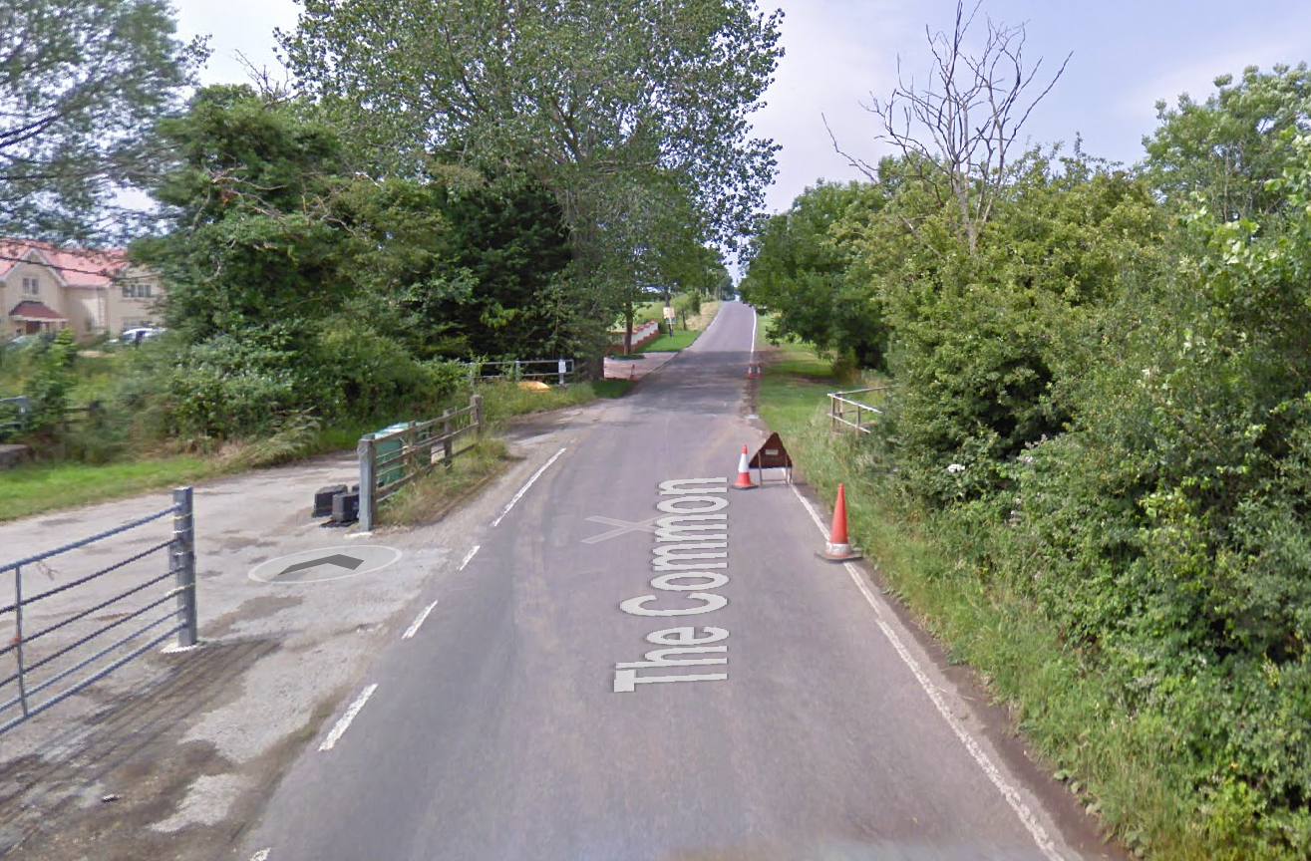
c) Main Loop
0.9 miles  + every  20 miles | X-road unclassified road The Common / Station Road / Silver St / /Malmesbury Road (B4040) | Turn left onto B4040 towards Malmesbury.  Traffic from right has priority. | M | Place 1 x observer wearing high visibility vest (optional).  Use 2 x Cycle Event warning signs on main road (if no observer) and 1 x Cycle Event warning signs on all approaches  Direction signs
 | Riders turn left onto B4040 - give way to traffic on right; limited visibility | 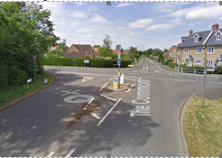
5.4 miles  + every  20 miles | Charlton Village, B4040 | Sharp Left/Right bend with narrow road | M | Cycle Event Warning Sign on B4040 west of hazard, for traffic travelling eastward (against flow of the event).  Warning on start sheet
6.5 miles  + every  20 miles | B4040 between Charlton and A429 RAB  Note: Narrow bridge on bend ½ mile before RAB | Sharp left turn, but with good visibility. | L | Warning on start sheet  Cycle Event Warning Sign on B4040 west of hazard, for traffic travelling eastward (against flow of the event).
7.1 miles  + every  20 miles | Follow to Malmesbury water tower (Crudwell) Roundabout: Junction B4040 / A429 by BP station | Turn left onto A429 at RAB heading South towards Southern Malmesbury RAB. Traffic from right has priority | L | Place 1 x observer wearing high visibility vest (not mandatory).  Visibility is good and junction is wide  Direction sign; Cycle Event warning signs on all approaches
 | Riders take first left exit to join A429 | 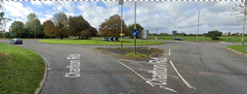
7.7 miles  + every  20 miles | 200 yds before RAB | Traffic Island in middle of Road for Waitrose | L | Notice at HQ Signing On
7.9 miles  + every  20 miles | Priory Roundabout (Malmesbury): Junction A429 / B4042 | Turn left onto B4042 at RAB.  Towards Brinkworth | L | Place 1 x observer wearing high visibility vest (not mandatory). Visibility is good and junction is wide  Direction arrow; Warning signs
 | Riders take first left exit to join B4042 | 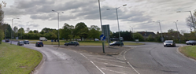
8.2 miles + every 20 miles | Descent to River Avon after RAB | Descent from top of hill towards River Avon and is fast. Drivers may hold up riders, especially if turning into Cowbridge Crescent, riders are not to overtake cars on the descent | L | Warning on start sheet to observe Highway Code  (As per Serial 6)
16.2 miles  + every  20 miles | Follow to Ballards Ash junction  B4042/B4696 junction | Turn left onto B4696 | L | Place 1 x observer wearing high visibility vest. (not mandatory). Riders have priority.  Cycle event warning signs, direction arrows  At least 2 direction arrows for riders, one in advance of the turn, and one on the turn.
 |  | 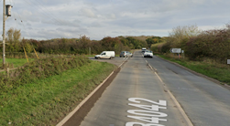
18.2 miles  + every  20 miles | Purton Road X-roads  Braydon Cross - junction | Turn left onto unclassified road towards Baydon House and Minety | L | Nil. Visibility is good and riders have priority.  Cycle event warning signs  Direction signs needed
 |  | 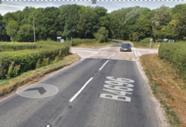 |  | Drain and 3 x hydrant covers on riders line
18.8 miles  + every  20 miles | Road turns North (right) after 0.65 mile while road appears to go straight on (which is actually turn onto another unclassified road) | Riders confused by the road layout, take wrong direction and need to turn | Nil | Direction arrow needed
 | Pass start and repeat x4 more times
d) Finish
100 miles | Finish | Riders sprinting for the line. Very quiet road | L
 | The finish is in line with the HP Gas Pole about 200m north of the start | 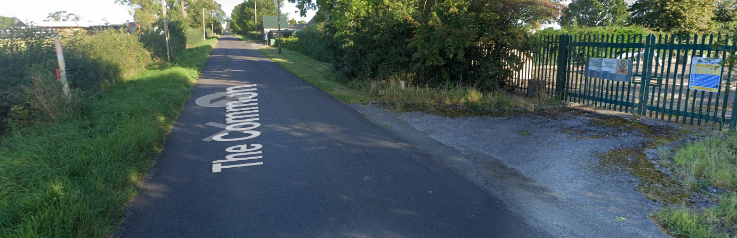
101 miles | Cross roads with B4040 | Riders Returning to HQ after finishing | L | Instructions on start sheet than on finishing proceed to the HQ and leave the course at the X in Minety.

Date of original Assessment: Late Summer/Early Autumn 2014
https://www.strava.com/activities/5462694164
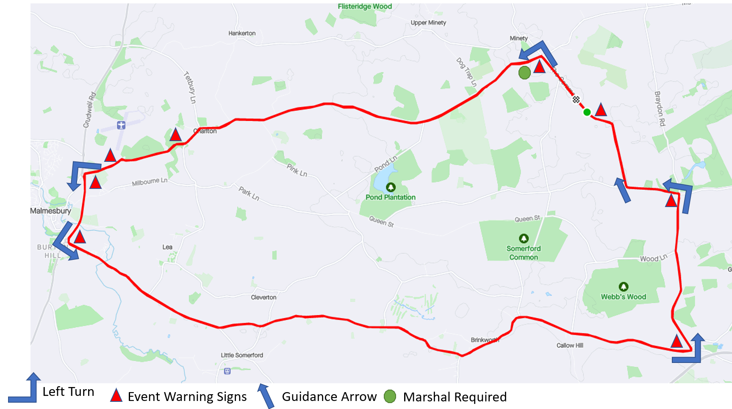

Important Notes
1. The course is generally expected to be quiet during the event
2. There are two sharp corners:
• In Charlton: This corner is blind to oncoming traffic, so take care
• Between Charlton and A429, crossing river bridge: This corner has good visibility, however unless you brake early you will cross the white central line, so look out very carefully for oncoming traffic.
4. There are 2 sharp turns at Baydon turn (riders have priority) and Minety turn (turn onto main B road, drivers have priority).
5. The descent to the Avon River after the southern Malmesbury RAB is a 30 mph zone. Be aware that drivers may slow to turn into the houses on the left. Care and observance of the Highway Code is required.
6. The onus is on the rider to know the course but all turns will be signed. There will be some officials on course doing traffic counts and ensuring course compliance.

