
West DC: Risk Assessment

Cycling Time Trials – West DC Course Risk Assessment Document. The measures to reduce risk identified in the right hand column must be included on the start sheet or implemented for the duration of the event as applicable. Failure to comply with the requirements of this document may result in approval being withheld with respect to subsequent race promotions by the promoting club.
(CTT Guidance Note 22 – Appendix 2 – Issue 2 September 2011 provides additional advice)

Course/Road(s) Assessed:  Bowden Hill, Lacock | Course:  UHC80 Bowden Hill  Distance (in miles):  1.2 mile
Date of Assessment/Review: | Name of Assessor:  Paul Winchcombe
Review History:  First Produced (if known): N/K  Last Review: 26 Aug 2023 | Sponsoring Club or Organisation:  Chippenham & District Wheelers
Course Description:
Start at entrance to Cottage (First cottage after the Chapel) 50m after bridge *. Proceed along Bewley Crescent and then across Bewley common, climbing Bowden Hill past the Rising Sun Public House * to cross Bowden Hill Common, turning the left hand corner at Bowden Hill House * and finishing at the top of the hill adjacent to the Spye Park * gates.
Link:
https://www.strava.com/activities/4144670737
Course Type:
- Single Carriageway
- Out only
- No traffic calming identified
Traffic Flows:
Traffic flow is low. Issues can be created if a descending vehicle causes an ascending vehicle to slow when a rider is behind them but there is no risk to the rider.
Course / Event History:
Course is used every year in October by Chippenham Wheelers for Hill Climb. Has been in use since at least 2010 with no issues.
This Risk Assessment only applies to Chippenham Club events which are run at start of September/end of August at 18130 hrs when traffic volumes are almost zero and there are fewer than 10 riders. This significantly reduces risk when compared to UH80 Risk Assessment
Police Authorities:
Wiltshire Constabulary - Mr Bob Eccleston. Bob.Eccleston@wiltshire.police.uk
Key Identified Risks

No. | Distance / Location | Risk/Hazard | Level of Risk  (L / M / H) | Measures to reduce Risk  (if applicable)
a) Introduction
1 | General Requirements | Time of Road Usage meets CTT Traffic Standards |  | Traffic counts within acceptable numbers ; Take Traffic Counts during event
b) HQ to Start
2 | Before Start | Competitors riding from Event HQ; Competitors warming up |  | Instructions on Start Sheet and at event HQ signing on advising riders of safe routes ; prohibition on warming up past the start
3 | Area of Start | Competitors waiting |  | Cycle Event warning signs; Instructions on Start Sheet and at event HQ signing on - warning against making ‘U’ turns.  Contact house owners to advise of the race start in the vicinity of their property.
 |  | 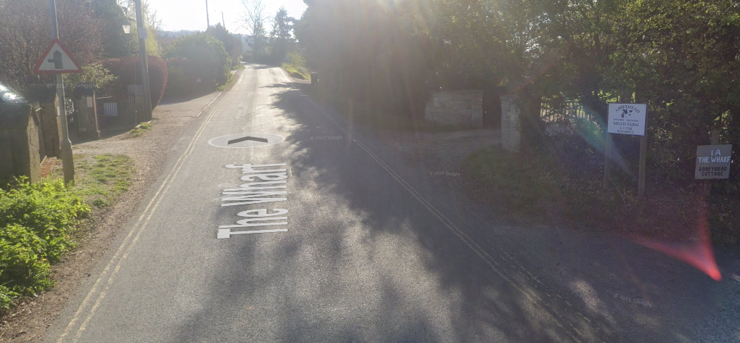
c) Start to Top of Hill

4 | 0.14 Bewley Lane | Cars turning onto Bowden Hill | L
5 | 0.16 Bell Pub car park entrance / exit | Cars turning onto Bowden Hill | L
6 | 0.29 Forest Lane | Cars turning onto Bowden Hill | L
7 | 0.77 Right bend in road | Riders cutting corner – on wrong side of road | L | Instructions on start sheet and at event HQ advising riders to keep left
8 | 0.86 Rising Sun Pub car park entrance / exit | Cars turning onto Bowden Hill | L
9 | 1.22 | Lack of room for overtaking cars where road narrows and bends left | L
10 | 1.27 | Finish where riders’ exhaustion may cause poor bike handling | L
11 | Through out event | Horses on road might be scared and force cyclists to take a wide path when overtaking | L | Instructions on start sheet and at event HQ that horses may be on the course. Letter to local stables advising of event.
 | Finish | Road Users – riders performing U turns after the finish | L | Warning on start sheet not to perform ‘U’ turns at the finish. Also a note to be aware of surroundings and other road users at the finish.
 |  | 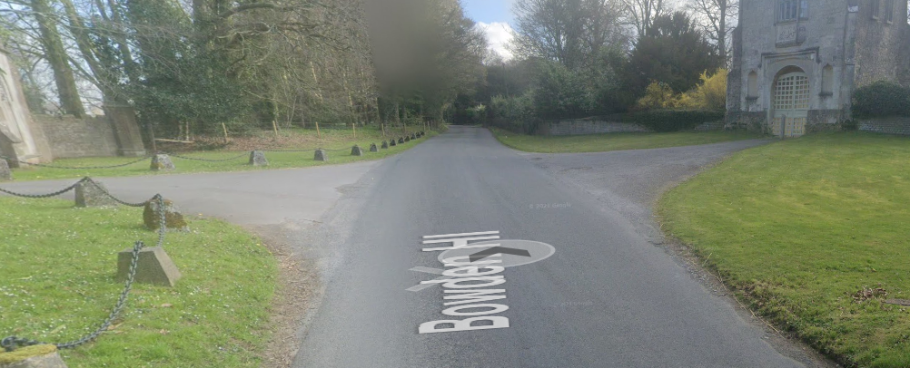

Notes
- The use of a vehicle for the timekeeper(s) at start and finish is where appropriate and is only identified as an example for the action to be taken
- The small junctions or entrances to farms/ facilities (garage,.eatery, etc) that are not identified in this risk assessment have been considered, however are not considered significant to pose a risk and therefore have not been noted.
- Observers on this course may be replaced by Cycle Event Warning signs as riders have priority over all joining traffic and speeds should be low.

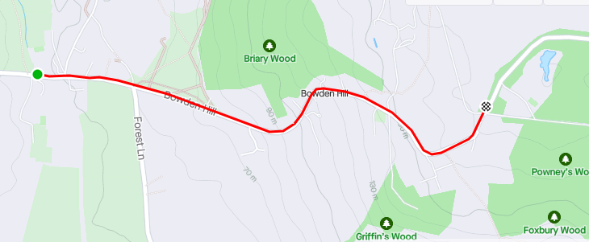
This document remains live and any changes to the items listed above or new hazards/risk that arise should be notified to the district committee at the earliest opportunity.

CYCLING TIME TRIALS IS A COMPANY LIMITED BY GUARANTEE REGISTERED IN ENGLAND No: 4413282
Registered Address: 77 ARLINGTON DRIVE, PENNINGTON, LEIGH, LANCASHIRE. WN7 3QP No

