
West DC: Risk Assessment

Cycling Time Trials – West DC Course Risk Assessment Document. The measures to reduce risk identified in the right hand column must be included on the start sheet or implemented for the duration of the event as applicable. Failure to comply with the requirements of this document may result in approval being withheld with respect to subsequent race promotions by the promoting club.
(CTT Guidance Note 22 – provides additional advice)
Course/Road(s) Assessed:  Bruton B3081 / B3092 | Course:  U303  Distance (in miles):  19 miles
Date of Assessment/Review:  16 March 2024 – updated with traffic calming | Name of Assessor:  Mike Smith
Review History:  First Produced (if known): N/K  Review Dates:  15 February 2024 – new format and 20mph approval  11 January 2024  20/11/23  13/01/2022  (Updated with junction images October 2022) | Sponsoring Club or Organisation:  Gillingham & District Wheelers
Course Description:
Start Bruton on B3081 (Wincanton road) at point level with industrial estate entrance (O/S grid ref. ST68 63 47). riders have priority at traffic calming measure under the bridge immediately after the start. proceed on B3081 to Stoney Stoke (2.5 miles – observer). turn left through Charlton Musgrove to give way sign at Leigh common (5.1 miles – observer). turn left onto old A303 (caution: traffic). continue through Bourton and Zeals to give way junction with b3092 (observer) . turn left onto B3092 (caution: traffic) towards frome for approx. 1.25 miles, then turn left to Kilmington Common (observer – rough road surface on turn). proceed across Kilmington Common (caution: short stretch of narrow road) to Yarnfield Gate, then turn sharp left (observer – caution – rough road surface on turn) approx. 13 miles. continue downhill (caution: steep – take care) through North Brewham to finish by double gates of electric substation approx. 200 yards short of junction with A359 in Bruton. After the finish proceed to the HQ, taking care not to disrupt traffic in the vicinity.
Link: https://www.cyclingtimetrials.org.uk/course-details/u303
All images are hyperlinked to Google Maps
Course Type:
- Single Carriageway
- Circuit
- Speed restriction at start (20mph) – riders not to overtake cars. Approved by West District Committee meeting on 9 February 2024
Traffic calming in Queen Oak, east of Bourton on New Road. Riders must give way..
Traffic Flows:
Traffic counts are very low.
Count taken on Saturday 13 January 2024 at approximately 1400 hrs was 120 units in direction of riders. (Oncoming traffic was also low at 102 units.)
Course / Event History:
Course has been used every year for since 2011 or earlier with no significant issues and is a WTTA Hardriders course
Course has been used twice since introduction of 20 mph limit with no issues
16 March 2024 – rider clipped a parked car on open road. Rider error. RA reviewed and no issues identified.
Police Authority:
Avon & Somerset Constabulary - Traffic Management Dept
Amanda Smith -Amanda.Smith@avonandsomerset.pnn.police.uk

Key Identified Risks
No. | Distance / Location | Risk/Hazard | Level of Risk  (L / M / H) | Measures to reduce Risk  (if applicable)
a) Introduction
1 | General Requirements | Time of Road Usage meets CTT Traffic Standards | L | Traffic counts within acceptable numbers; Take Traffic Counts during event, check course for hazards
b) HQ to Start
2 | Before Start | Competitors riding from Event HQ; Competitors warming up | M | Instructions on Start Sheet and at event HQ signing on advising riders of safe routes; prohibition on warming up past the start
3 | Area of Start | Competitors waiting | L | Instructions on Start Sheet and at event HQ signing on - warning against making ‘U’ turns; Cycle Event Warning signs
 | What3Words  bathtubs.makes.touches | 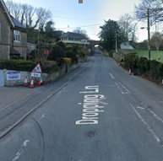
c) Start to Finish
4 | B3081: Bruton-Redlynch X Roads (1.5M) | Two way traffic: narrow bridge, priority to cyclists. 4 minor junctions, | L | Warning sign at bridge for oncoming traffic
 | This section has been a 20mp limit since at least 2021. Goes uphill and riders unlikely to exceed 20mph. Note priority over oncoming traffic. | 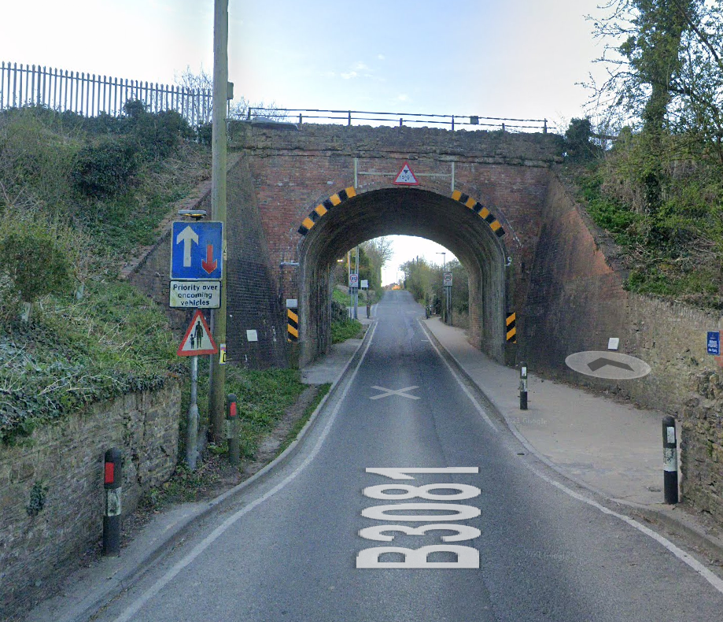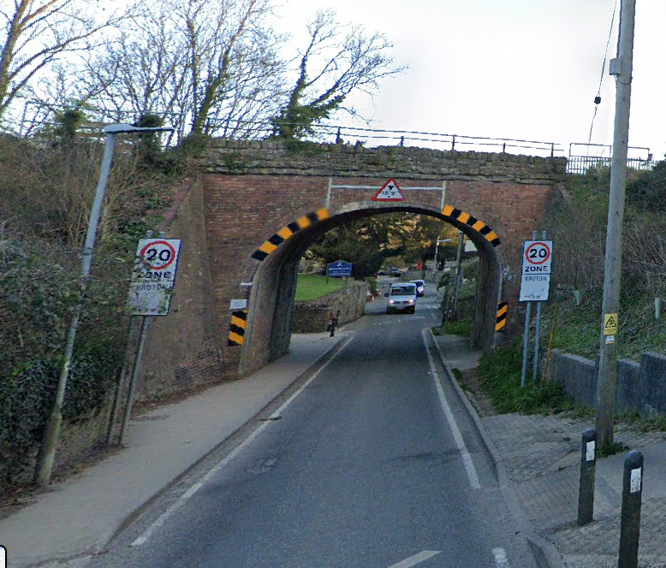  View uphill for riders View downhill for drivers with 20mph sign
5 | B3081: R’Lynch to left fork at Stoney Stoke (2.5M) | Slight risk from traffic also turning left at junction. | L | Observer (optional as riders have priority), Cycle Event Warning signs
 |  | 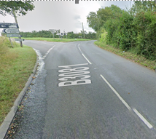
6 | B3081 to old A303 junction | Two way traffic: 4 minor junctions, undulating section | L | No additional measures required
7 | Turn left at T Junction onto old A303 (5M) | Fast traffic coming from right (Wincanton direction) on unclassified road | M | Observer, Cycle Event Warning signs
 |  | 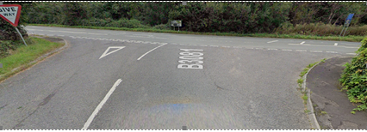
8 | Onto Bourton road sign (6M) | Traffic merging from A303 junctions | L | Cycle Event Warning signs
9 | Through Bourton to Bourton Cross Roads (7.5M) | Past several minor junctions: cyclists have priority on old A303. | L | No additional measures required
 | Queen Oak, east of Bourton | Traffic calming – road narrows | L | Riders must not push through if there is oncoming traffic
 |  | 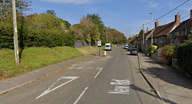
10 | Bourton X Roads to Zeals | Past several minor junctions: cyclists have priority on old A303. | L | No additional measures required
11 | Zeals to T Junction B3092 (8.75M) | Past several minor junctions: cyclists have priority on old A303.Traffic calming measures in Zeals with alternate priority for traffic. | M | Cycle Event Warning signs
12 | Turn left at T Junction onto B3092 | Downhill to turn: heavier traffic on B3092 travelling at speed between Mere & Frome | M / H | Two observers required; Cycle Event Warning signs; competitors warned of hazard on Start Sheet
 |  | 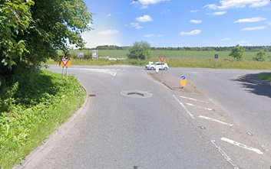
13 | B3092 to Kilmington Turn off (10.5M) | Past busy junction (to Stourhead) | M | Cycle Event Warning signs on Stourhead junction
14 | Turn left towards Kilmington Street (on Stourton Lane) |  | L | Observer, Direction sign
 |  | 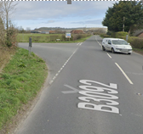
15 | Continue through Kilmington Street | Road narrows for short section (11M): danger of oncoming traffic in centre of road | L | Cycle Event Warning sign
16 | Continue on to Yarnfield Gate junction (13M) | Cross small crossroads | L | No additional measures required
17 | Turn left into Druley Hill | Uneven Road surface on corner: traffic from right has priority | L | Observer; Cycle Event Warning sign at junction
 |  | 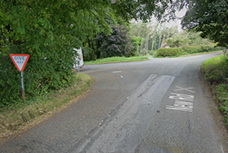
18 | Descend Druley Hill | Long descent at speed | M | Warn riders on Start Sheet and at Event HQ
19 | North Brewham | 30 mph zone, rough road surface | L | Warning on startsheet
20 | Continue on to finish (18.75M) | finish at lay-by just outside Bruton | L | Cycle Event Warning sign beyond lay-by for oncoming traffic
 |  | 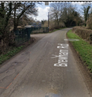
21 | Finish |  | M | Cycle Event Warning signs in both directions
22 | Return to HQ | Short ride to HQ, minor junctions | Low | On start Sheet - Instructions on following route to HQ and Warning regarding U turns

Notes
- The use of a vehicle for the timekeeper(s) at start and finish is where appropriate and is only identified as an example for the action to be taken
- The small junctions or entrances to farms/ facilities (garage, eatery, etc) that are not identified in this risk assessment have been considered, however are not considered significant to pose a risk and therefore have not been noted.
- Druley Hill descent is fast and riders must be aware of farm entrances.

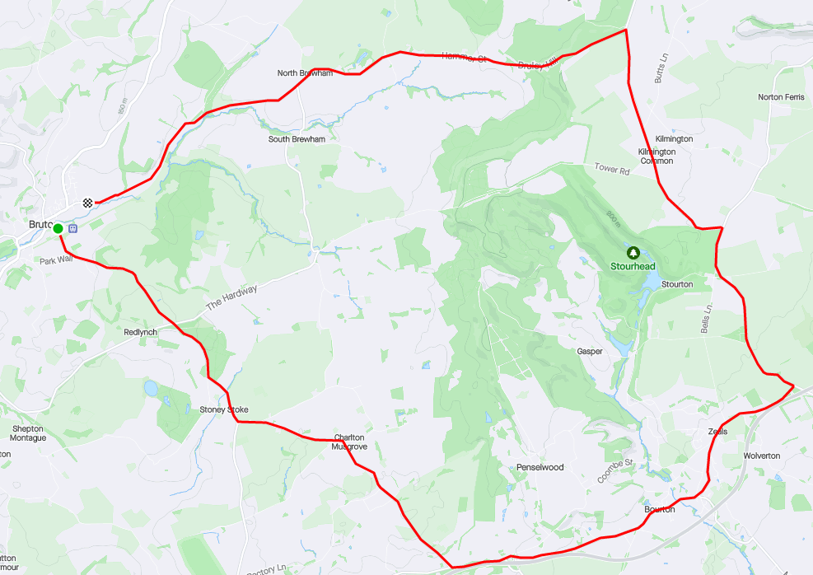

This document remains live and any changes to the items listed above or new hazards/risk that arise should be notified to the district committee at the earliest opportunity.

