 | West DC: Risk Assessment

Course Identification: U57 (single or double lap)

Course: U57 | Road(s) Assessed: A361 / A342 / Broad Street / Horton Road
Pages: 3 | Date of Assessment :01 September 2017

Cycling Time Trials – West DC Course Risk Assessment Document. The measures to reduce risk identified in the right hand column must be included on the start sheet or implemented for the duration of the event as applicable. Failure to comply with the requirements of this document may result in approval being withheld with respect to subsequent race promotions by the promoting club.

Restrictions:

No. | Distance / Location | Risk/Hazard | Level of Risk  (L / M / H) | Measures to reduce Risk  (if applicable)
a) Introduction
1 | General Requirements | Time of Road Usage meets CTT Traffic Standards |  | Traffic counts within acceptable numbers ; Take Traffic Counts during event
b) HQ to Start
2 | Before Start | Competitors riding from Event HQ; Competitors warming up |  | Instructions on Start Sheet and at event HQ signing on advising riders of safe routes ; prohibition on warming up past the start
3 | Area of Start | Competitors waiting |  | Cycle Event warning signs; Instructions on Start Sheet and at event HQ signing on - warning against making ‘U’ turns
c) Start to xxx
4 | SU032642 | T Junction with A361 | M | Cycle Event warning signs and marshal
5 | Horton Road R/bout | Roundabout | M | Cycle Event warning signs and marshal
6 | Hopton Road R/bout | Roundabout | L | SO sign
7 | A361/Windsor Drive R/bout | Roundabout | M | Cycle Event warning signs and marshal
8 | Pedestrian Lights Windsor Drive | Traffic Lights Pedestrian Controlled | L | Marshal to politely request pedestrians do not push button and impede riders
9 | Nursteed Community School Roundabout | Roundabout SO | L | SO sign
10 | Nursteed Cottage Roundabout | Roundabout SO | L | SO sign
11 | Junction with A432 | Roundabout Left turn 1st Exit | M | Cycle Event warning signs and marshal
12 | Junction with A432 | Roundabout SO | L | Cycle Event warning signs and marshal
13 | Wedhampton | B3098 approaches from right | L | Cycle event warning sign
14 | Rushall Junction A342 & minor road Turn Left | Left Turn | L | Cycle event warning sign and marshal
15 | Woodbridge Inn. Junction A345 and Minor road Turn Left | Left Turn at Roundabout | L | Cycle event warning sign and marshal
16 | Hillcott | Road bears right | L | Direction sign for riders and cycle event warning sign on approach
17 | Woodborough | Road narrows Traffic calming adjacent to School after crossing railway | L | Cycle event warning signs
18 | Alton Barnes | Left Turn | L | Cycle Event warning signs & marshal
19 | Allington S bend | Sharp bends | L | Cycle event warning signs
20 | For Single Lap Finish is @ SU 03976 63244 | Road Users – riders performing U turns after the finish |  | Warning on start sheet not to perform ‘U’ turns at the finish. Also a note to be aware of surroundings and other road users at the finish.
20 | Finish @ SU041632 |  | m | Riders to continue canal bridge and take right turn back to Bishops Cannings & HQ
 | Riders completing 2nd lap
21 | Junction with A361 Devizes | Turn left at Roundabout | M | Cycle event warning signs and Marshal
22 | Roundabout Hopton Industrial Estate | Busy Roundabout | M | Cycle Event warning signs and marshal
23 | Roundabout to A342  Eastern Ringroad | Roundabout | L | Cycle Event warning signs and marshal
 | Finish | Road Users – riders performing U turns after the finish |  | Warning on start sheet not to perform ‘U’ turns at the finish. Also a note to be aware of surroundings and other road users at the finish.

Course Description:

Start at GR SU032642. Proceed to T Junction with A361 *. Turn Left onto A361 towards Devizes. At Horton Roundabout take 2nd Exit straight over **. At Hopton Industrial Estate Roundabout SO *. At Windsor Road/A361 Roundabout Turn Left *At Nursteed Community school and Nursteed Cottage Roundabout continue straight on to A432/Windsor Drive Roundabout.* Take first exit left turn to next roundabout. * Take first exit remaining on A432. Continue on A342 through Lydeway, Wedhampton to Rushall. At T Junction * Turn Left into Rushall and on towards Woodbridge Inn roundabout. * Take 1st Exit towards Woodborough.In Alton Barnes Turn Left * towards Horton. Finish at GR SU 03976 63244 (for single lap of course which is 20.7 miles)

https://ridewithgps.com/routes/25127379

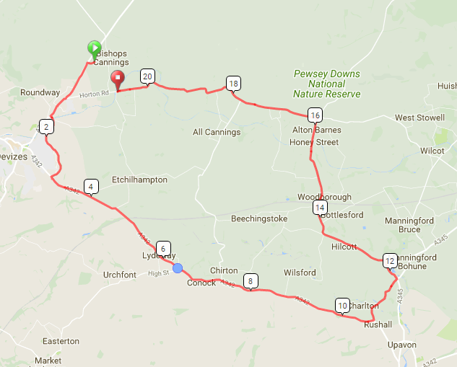

This document remains live and any changes to the items listed above or new hazards/risk that arise should be notified to the district committee at the earliest opportunity. This document was last updated on 10 September 2017.

CYCLING TIME TRIALS IS A COMPANY LIMITED BY GUARANTEE REGISTERED IN ENGLAND No: 4413282
Registered Address: 77 ARLINGTON DRIVE, PENNINGTON, LEIGH, LANCASHIRE. WN7 3QP November 2003

