
West DC: Risk Assessment

Cycling Time Trials – West DC Course Risk Assessment Document. The measures to reduce risk identified in the right hand column must be included on the start sheet or implemented for the duration of the event as applicable. Failure to comply with the requirements of this document may result in approval being withheld with respect to subsequent race promotions by the promoting club.
(CTT Guidance Note 22 – Appendix 2 – Issue 2 September 2011 provides additional advice)
Course/Road(s) Assessed:  A417 – A419 | Course:  U46C  Distance (in miles):  25 Miles
Date of Assessment/Review:  26 January 2023  Date of production February 2022 | Name of Assessor:  Billy Oliver  Updated by Paul Winchcombe with Google Images (hyperlinked)
Course Description:
start in bus stop on north side of road, between the roundabout off the cricklade south exit of a419 dc, and the roundabout at the edge of cricklade. proceed east to the roundabout for the a419dc. take the first exit, cirencester a419. proceed north west on the a419 dc, becoming the a417 dc exit at the burford road exit of the a417. at end of the slip road circle the roundabout to take 3rd exit toward burford. pass over the a417 dc to roundabout. take 3rd exit signed swindon a419 to rejoin the a417 dc. continue on the a417 dc becoming the a419 dc. exit at the cricklade exit, to cross over the top of the dc. at the roundabout (first roundabout encountered at the start) circle the roundabout to take the 4th exit, signed cirencester a419. proceed north west on the a419 dc. exit when the a419 leaves the dc signed cirencester industrial area. at the roundabout circle to take the 3rd exit, signed swindon a419, to rejoin the dc. proceed south east on the a419 dc. exit at the cricklade exit, to finish on the slip road. total course distance - 25 miles
Link:
https://www.cyclingtimetrials.org.uk/course-details/u46c
https://www.strava.com/activities/7185353077/

Traffic Flows:
(A general description of traffic count on major roads on course with a traffic count number which is at a similar time to the courses normal time of use)
Updated traffic count from 2022 event needed
Course / Event History:
Course has been in use since at least 2013. Use was suspended for several years after some traffic incidents where clubs did not wish to use the course. Course was recommissioned in 2022.

No events in poor visibility – see footnote.
No. | Distance / Location | Risk/Hazard | Level of Risk | Measures to reduce Risk
No. | Distance / Location | Risk/Hazard | (L / M / H) | (if applicable)
a) Introduction
1 | General Requirements | Time of Road Usage meets CTT Traffic Standards; | L | Traffic counts within acceptable numbers ; Take Traffic Counts during event;
2 | General Requirements | Weather conditions are acceptable – no excessive spray or fog. | H | Delay start or cancel event.
b) HQ to Start
3 | Before Start | Competitors riding from Event HQ; Competitors warming up | L | Instructions on Start Sheet advising riders of safe routes and alternative parking ; prohibition on warming up past the start
4 | Area of Start – Bus Stop at outskirts of Cricklade | Congregation of competitors waiting, give a large moving target | M | Instructions on Start Sheet – warning against making ‘U’ turns ; Cycle Event Warning sign;  Don't hold events when bus stop is in use
 |  | 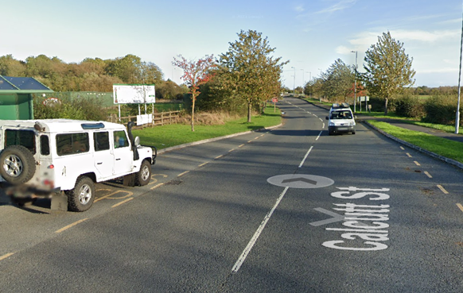
c) Start to Finish
4 | Bus Stop at Start | Competitors starting pulling out into traffic | L | Use the course only when traffic counts acceptable.  Cycle event sign prior to bus stop
5 | RAB at end of Cricklade sliproads to DC | Traffic on RAB and competitors come together | L | Good sight lines, competitors take first exit.  Cycle event sign on slip road approach to RAB from A419.  Optional observer on RAB
 | Riders take first exit | 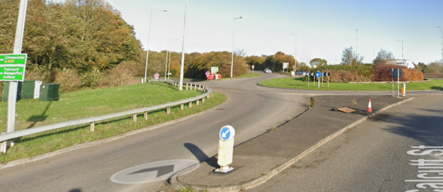
6 | Joining the A419 DC | Riders enter the DC, traffic on the DC | M | Large Cycle Event Warning sign on dual carriageway before slip road
7 | Passing the North Cricklade junction | Traffic entering the DC, with riders on the DC | M | Warning sign prior “RAB” at the start of slip road to the DC
7.1 | Passing the North Cricklade junction | Traffic entering the DC, with riders on the DC | M | Warning sign on exit of “RAB” start of slip road to the DC
8 | Passing the Spine Road Junction | Traffic travelling north entering the DC, with riders on the DC | M | Warning sign at exit of Spine Road west RAB.
9 | Passing the Cirencester exit of the A419 from the DC | Riders on 2nd lap leaving the course, cars taking the exit whilst riders continue | M | Note on start sheet that riders exit first and second laps in different places.  Cars exiting covered by Risk #6
10 | Burford Road exit of DC | Riders leave the DC | L | Riders have right of way,and stay on the left.  Start sheet to make clear riders need to know the course in advance.
 | Exit is at 7.2 miles  Signposted A249 Cirecencester / Stow | 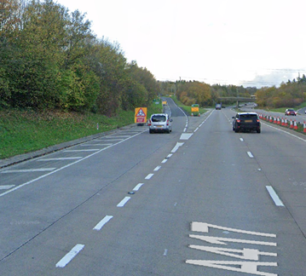
11 | RAB Burford Road West | Riders enter the RAB | M | Event warning sign on Burfroad west of RAB.  Observer on RAB to confirm full course has been ridden
 | Riders take 3rd exit  Riders have good visibility of traffic on RaB | 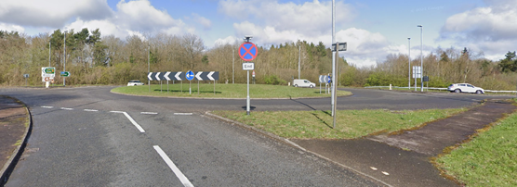
12 | RAB Burford Road East | Riders enter the RAB | L | Little traffic on entering the RAB. Event warning sign on the Burford Road East of the RAB.  Optional observer on RAB
 | Riders take 3rd exit signed M4 Swindon A419  Riders have good visibility of traffic on RaB | 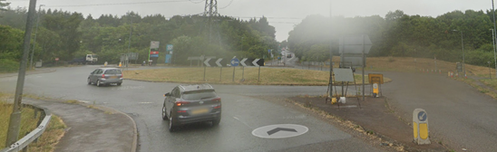
13 | Riders rejoin the A417 DC from the Burford Road junction | Riders entering the DC | H | Large Event Warning sign on the DC before the sliproad.
14 | Riders pass A419 joining the DC Junction | Traffic/competitors joining the DC from A419 | M | Warning signs on the A419, covered by Risk #23.1 & #24  Warning on start sheet that 1st and 2nd laps turn at different points.
15 | Riders pass the Spine Road Junction | Traffic leaving/joining the DC to/from the spine road | M | Warning sign on leaving the Spine road East RAB for the DC.
16 | Riders pass the South Latton junction | Traffic joining the DC from south Latton | M | Warning sign on leaving the South Latton RAB for the DC.
17 | Riders exit at the Cricklade Exit | Riders Leave the DC | L | Riders have right of way and stay left. Start sheet to make clear riders need to know the course in advance.
 | Exit is at 14.9 miles  Signposted Cricklade / Purton B4040 | 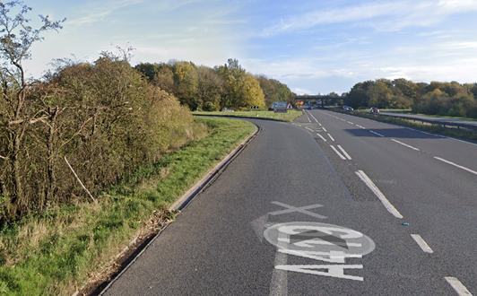
18 | Slip road off the DC at Cricklade | Riders may pass riders who are just starting | L | Warning on start sheet that finishing riders should continue on the slip road keeping well left.
19 | RAB at end of Cricklade Slip road | Riders on first and second laps meet | L | Observer
 | Riders take 3rd exit  Signposted Cirencester A419 | 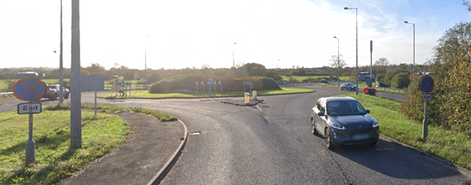
20 | As 6
21 | As 7
22 | As 8
23 | Riders leave the DC on the A419 | Riders on first and second laps, and traffic exiting the DC | L | Note on start sheet that riders exit first and second laps in different places.
 | Exit is at 19.8 miles  Signposted Cirencester Industrial Area / Stroud A419 | 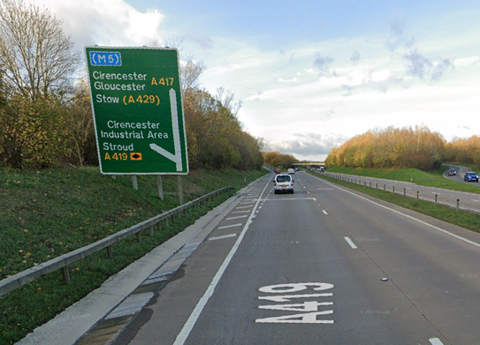
23. | RAB on A419 exit of the DC | Traffic on the RAB | M | Riders have right of way over most traffic.  Sign on Old Road approaching the RAB.
 | Riders take 3rd exit  Signposted M4 Swindon A419 | 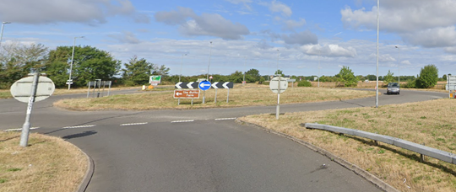
24 | RAB on A419 exit of the DC | Traffic on the RAB | M | Riders have right of way over most traffic.  Sign on the A419 approaching the RAB.  Optional observer.
25 | Riders rejoin the DC from the A419 slip road on second lap | Riders and traffic on the DC completing first lap and Riders and Traffic Joining the DC on second lap. | M | Traffic\Riders joining covered by risk #14  Large Cycle Event Warning sign on dual carriageway before slip road warning DC traffic  Note on start sheet that riders exit first and second laps in different places.
26 | As 15
27 | As 16
28 | As 17  Exit is at 24.8 miles
29 | The finish | Riders on first lap continue | M | Note on start sheet that riders pass finish on first lap when other riders may be finishing.  Note on start sheet for riders to keep left after finishing, continue on slip road to return to HQ.

Footnote: Include on start sheet:
Please note: A large part of this course is a dual carriageway and if the weather is poor the visibility deteriorates quickly. The event will be delayed or cancelled if there is a danger to riders.

This document remains live and any changes to the items listed above or new hazards/risk that arise should be notified to the district committee at the earliest opportunity. This document was last updated on February 2022.

Course Description
Start in bus stop on North side of road, between the roundabout off the Cricklade South exit of A419 DC, and the roundabout at the edge of Cricklade.
Proceed East to the roundabout for the A419DC.
Take the first exit, Cirencester A419.
Proceed North West on the A419 DC, becoming the A417 DC
Exit at the Burford Road exit of the A417. At end of the slip road circle the roundabout to take 3rd exit toward Burford. Pass over the A417 DC to roundabout. Take 3rd exit signed Swindon A419 to rejoin the A417 DC.
Continue on the A417 DC becoming the A419 DC.
Exit at the Cricklade exit, to cross over the top of the DC. At the roundabout (first roundabout encountered at the start) circle the roundabout to take the 4th exit, signed Cirencester A419.
Proceed North West on the A419 DC.
Exit when the A419 leaves the DC signed Cirencester Industrial Area. At the roundabout circle to take the 3rd exit, signed Swindon A419, to rejoin the DC.
Proceed South East on the A419 DC.
Exit at the Cricklade exit, to finish on the slip road.

Start Description
Start is in the bus stop of the North side of the road (for trafic eastward), bus stop between the two roundabouts to the east of Cricklade on the B4040, the exit roundabout for the A419 DC, and the next roundabout on the edge of Cricklade. The start is in line with the eastern edge of the drain cover in the middle of the bus stop, almost immediately opposite lamp post #32.

Finish Description
Finish on the slip road, on the Cricklade exit of the A419DC travelling south.
The finish is in line with the start of the exit off the slip road, to a dead end road, immediately before the slip road crosses over the A419 DC.
https://www.strava.com/activities/7185353077
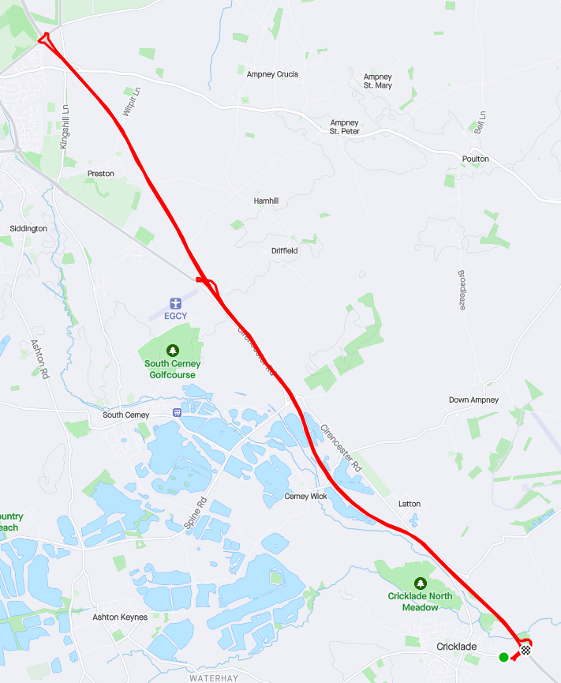
CYCLING TIME TRIALS IS A COMPANY LIMITED BY GUARANTEE REGISTERED IN ENGLAND No: 4413282
Registered Address: 77 ARLINGTON DRIVE, PENNINGTON, LEIGH, LANCASHIRE. WN7 3QP November 2003

