 | West DC Risk Assessment
Course/Road(s) Assessed: B3092, A361, A359 | Course: U33  26 Miles
Date of Assessment/Review: 30/04/2022  Updated by Paul Winchcombe to include images with links | Name of Assessor: Adrian Shephard
Course Description
Starting on the unclassified road, 50 yards from the junction of Yellow Way Road, Maiden Bradley and Gare Hill Road.
Left turn at junction to Kilmington onto New Road and Stourton Lane.
Left turn onto B3092 towards and through Maiden Bradley.
Left turn for Tytherington Bulls Quarry Road.
Left turn onto A361 to top of “Ski Slope” roundabout.
Left turn to continue on A361 to Nunney Catch roundabout.
Left turn onto A359 then continue through Wanstrow to Bruton.
In Bruton left turn onto unclassified Brewham Road, through North Brewham and up Druley Hill to finish near the start.

Link:
https://www.strava.com/activities/7107233084
https://www.cyclingtimetrials.org.uk/course-details/u33

Traffic Flows: Low traffic flow for the unclassified roads that make up about a third of the course. Low traffic flow on the B3092 and the A359, and low to moderate on the A361 at the time of the event.
Course/Event History:
The course has been used for time trials by local clubs since 2014. I am not aware of any incidents.

Key Identified Risks
Distance | Location | Identified Significant Risk/Hazards | Level of Risk  Low/Med/High | Measures to reduce Risk  (if applicable)
0 miles | HQ to start  START Starting on the unclassified road, 50 yards from the junction of Yellow Way Road, Maiden Bradley and Gare Hill Road. | Competitors riding to start from HQ. Minimal traffic. Route avoids course except for crossing it in Maiden Bradley.  Waiting competitors at start | Low  Low | Instructions to avoid warming up on the course and to avoid U turns on start sheet and at HQ. On the day risk assessment at sign-on. Observer at crossroads in Maiden Bradley. Cycle Event warning signs on all approach roads. Officials at the start.
 |  | 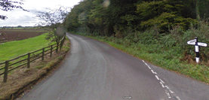A
0.5 miles | Left turn on to New Road | Minor junction with low traffic | Low | Cycle event warning sign at junction. Course direction sign for competitors.
 |  | 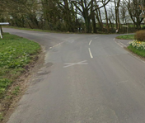
3 miles | Left turn onto B3092 towards Maiden Bradley | Joining B road with moderate traffic from right | Med | Observer and Cycle Event warning signs.
 |  | 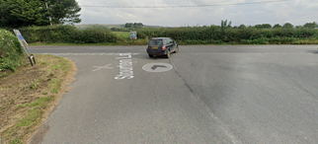
7 miles | Through Maiden Bradley | Traffic calming measures so riders may need to give way to oncoming traffic | Med | Cycle Event warning signs at each end of calming. Observer at south end. Warning on Start Sheet to give way if required.
 |  | 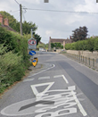
11 miles | Left turn to Bulls Quarry Road | Joins minor road with low traffic | Low | Cycle Event warning sign. Observer
 |  | 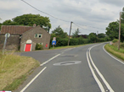

12.5 miles | Left turn to A361 Frome bypass aka “Ski Slope” | Joins main road, medium traffic at speed from right | Med | Cycle Event warning signs on A361 in both directions. Observer opposite junction
 |  | 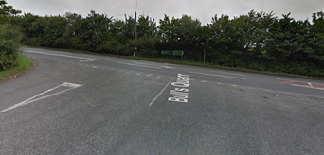
13 miles | Left turn at rbt continues on A361 | Turns with flow of traffic, left turn lane available, medium traffic | Med | Warning signs at all rbt entry points.  Observers at entry and exit of rbt
 |  | 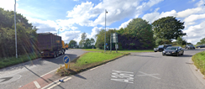
15 miles | Left turn at Nunney Catch rbt | Turns with flow of traffic,left turn lane available, medium traffic | Med | Warning signs on approach to rbt on A361 and A359. Observer
 |  | 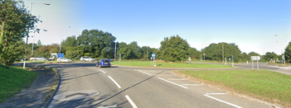
17 miles | A359 downhill through Wanstrow | Possible cars parked with riders approaching at speed. | Low | Warning on start sheet. Cycle Event signs in village
20 miles | Descent on A359 into Bruton | Recent road works due to housebuilding. Uneven surfaces, mud and gravel on road possibly. Works access. Parked cars | Low | Warning on start sheet. Cycle Event signs at top and bottom of this section
21 miles | Left turn to Brewham Road in Bruton | Very sharp turn at bottom of steep hill. Turns away from low traffic flow. | Med | Warning on start sheet. Cycle Event sign and Observer at turn  Extreme care needed when wet
 |  | 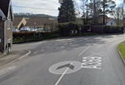
22 miles | Road merges to right onto Hammer Street in direction of Brewham  Riders go under railway bridge | Unclassified road. Low traffic. | Low | Cycle Event sign
23 miles | North Brewham | Possibility of farm traffic crossing road | Low | Low risk of animals being on road at time of event. Warning on start sheet.
26 miles | Finish timekeeper at Kilmington  Finish to HQ | Riders sprinting to finish. Unclassified road with low traffic  Three miles on quiet road | Low  Low | Cycle Event warning sign past finish.  Instructions on start sheet. No stopping at finish. Continue back to HQ.

Notes
- The use of a vehicle for the timekeeper(s) at start and finish is where appropriate and is only identified as an example for the action to be taken
- The small junctions or entrances to farms/ facilities (garage,.eatery, etc) that are not identified in this risk assessment have been considered, however are not considered significant to pose a risk and therefore have not been noted.
- Riders should be aware of possible everyday hazards from side turnings, farm entrances, mud, gravel and potholes as this is a rural course

Date of original assessment: 02/03/2019

