
West DC: Risk Assessment

Cycling Time Trials – West DC Course Risk Assessment Document. The measures to reduce risk identified in the right hand column must be included on the start sheet or implemented for the duration of the event as applicable. Failure to comply with the requirements of this document may result in approval being withheld with respect to subsequent race promotions by the promoting club.
(CTT Guidance Note 22 – Appendix 2 – Issue 2 September 2011 provides additional advice)

Course/Road(s) Assessed:  (A and B road designators with relevant village names) | Course:  U32R Hardriders  Distance (in miles):  24
Date of Assessment/Review:  27 September 2022 | Name of Assessor:  Paul Winchcombe  Reviewed 2019 RA and reapproved  Updated 2 Jan 23 with street views (these are hyperlinked)
Course Description:
(This should allow major turns, start and finish to be identified. This may be the course description used in the Police Notification Form.)
Link:
https://www.strava.com/activities/6853160414
Traffic Flows:
Traffic counts are low. Occasional bunching due to parked cars in Mere.
Course / Event History:
Course has been in annual use since at least 2012 with no incident.

No. | Distance / Location | Risk/Hazard | Level of Risk  (L / M / H) | Measures to reduce Risk  (if applicable)
a) Introduction
1 | General Requirements | Time of Road Usage meets CTT Traffic Standards | Low | Traffic counts within acceptable numbers; Take Traffic Counts during event
b) HQ to Start
2 | Before Start – HQ at Maiden Bradley | Competitors riding from Event HQ; Competitors warming up - avoid using the course as much as possible | Med | Instructions on Start Sheet and at event HQ signing on advising riders of safe routes; prohibition on warming up on course – use finishing lane
3 | Competitors riding to start | Negligible, route avoids course or need for U turns | Low | Route to be on start sheet and warning that U turn will result in disqualification
4 | Area of Start – layby on B3092 northbound | Competitors waiting; light traffic | Low | Cycle Event Warning signs;  Instructions on Start Sheet and at event HQ signing on - warning against making ‘U’ turns
 | 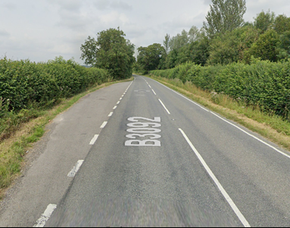
c) Start to Finish
5 | Blatchbridge Roundabout – 4th exit, B3092 southbound | Riders turn back onto B3092; traffic joining course in three directions | Med | 3 observers (optional as direction arrows can mitigate need for direction indication); Turn on Roundabout sign; 3 Cycle Event Warning signs for traffic joining the course
 | 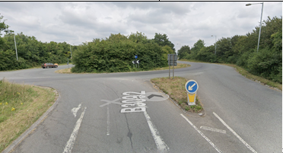
6 | Maiden Bradley village and X Road | Traffic calming and parked cars; Blind junction to left, Quiet at time of event | Low | Warning on Start Sheet; Cycle Event Warning sign in left junction
 | 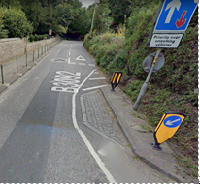
7 | Mere | Various roads, some bends, some cars parked. Zebra crossing on leaving Mere. Fairly quiet at time of event. | Med | Instruction to riders on Start Sheet to take great care
 | 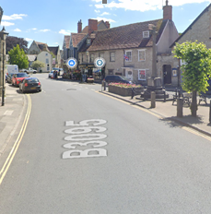 |  |  | Cycle Event Warning sign on lamp post outside the front of old Lloyds Bank (vacant building next to Walton House Antiques), facing direction of the George Inn
 |  |  |  | Traffic Island out front of Waltons of Mere/PO. Cycle Event Warning Sign on “No Entry” post
 |  |  |  | Observer (in high vis top) in the centre of Mere
8 | Descent of Kingston Deverill Hill | Sharp left and then right hand bend | Low | Instruction to riders on Start Sheet to take “great care”
 | 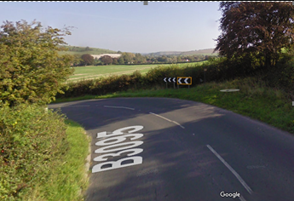  When wet care needed |  | 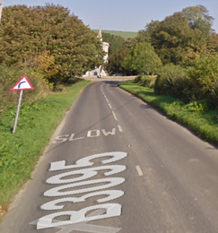  Blind bend
9 | The Deverill villages – all small | Route should be clear but risk of mud on road | Low | Warning on start sheet “Take care through villages’’ and warning of potential for mud
10 | Left on to A350 at Longbridge Deverill | Left turn on to main road; traffic from the right has priority and is joining the course | Med | Observer;  Cycle Event Warning sign on A350
 | 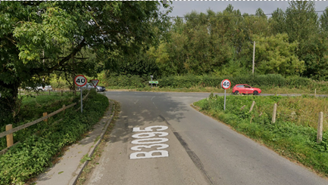
11 | Left onto minor road to Maiden Bradley after 100 yards on A350 | Riders turn left onto narrow road; traffic on minor road approaching the junction | Low | Observer (optional, riders have right of way);  Cycle Event Warning sign on minor road for traffic approaching the junction
12 | Shearwater Turning | Poor visibility for drivers joining the course from the Shearwater Turning | Low | Cycle Event Warning sign on Shearwater road approaching the junction – about the Give Way sign
13 | Finish Time Keeper (layby) on right shortly before Maiden Bradley sign | Riders sprinting to the finish; other road users; traffic joining the course from Maiden Bradley | Med | Cycle Event Warning sign for traffic joining the course
14 | After finish | Short ride back to the HQ | Low | Instruction to riders: no stopping at timekeeper. Continue along minor road to HQ

Notes
- The use of a vehicle for the timekeeper(s) at start and finish is where appropriate and is only identified as an example for the action to be taken
- The small junctions or entrances to farms/ facilities (garages,.eatery, etc) that are not identified in this risk assessment have been considered, however are not considered significant to pose a risk and therefore have not been noted.

This document remains live and any changes to the items listed above or new hazards/risk that arise should be notified to the district committee at the earliest opportunity. This document was last updated on February 2011.

CYCLING TIME TRIALS IS A COMPANY LIMITED BY GUARANTEE REGISTERED IN ENGLAND No: 4413282
Registered Address: 77 ARLINGTON DRIVE, PENNINGTON, LEIGH, LANCASHIRE. WN7 3QP November 2003

