
West DC: Risk Assessment

Cycling Time Trials – West DC Course Risk Assessment Document. The measures to reduce risk identified in the right hand column must be included on the start sheet or implemented for the duration of the event as applicable. Failure to comply with the requirements of this document may result in approval being withheld with respect to subsequent race promotions by the promoting club.
(CTT Guidance Note 22 – provides additional advice)

Course/Road(s) Assessed:  A303 | Course:  U30/10  Distance (in miles):  10
Date of Assessment/Review:  8 April 2024 – images added | Name of Assessor:  Tom Cox
Review History:  First Produced (if known): 30 May 2005  Last Review:  1 May 2022  Updated to revised format by Paul Winchcombe 25 January 2023 | Sponsoring Club or Organisation:  West District
Course Description:
Start at the 2nd drain cover west of the 30mph sign on the western side of Podimore village. Proceed to Podimore roundabout and take first exit (A303 westwards), continue straight along the A303 to the Tintinhull/Ash flyover, immediately after passing under the flyover turn left (signpost Tintinhull). At the T-junction turn left over the bridge and then left again – adverse camber – (signpost London), then left to rejoin the A303 eastwards. Take care when rejoining the A303 at the turn there is no slip road, keep in close to the kerb. Retrace to finish approx 400 metres before Podimore roundabout
Link:
https://www.cyclingtimetrials.org.uk/course-details/u30-10
Traffic Flows:
(A general description of traffic count on major roads on course with a traffic count number which is at a similar time to the courses normal time of use)
Updated traffic count is needed
Course / Event History:
Course has been in use since at least 2005 with no reported incidents.
Course Type:
- Dual Carriageway
- Out and Back
- No traffic calming or 20mph speed restrictions
Police Authorities:
Avon & Somerset Constabulary | Amanda.Smith@avonandsomerset.pnn.police.uk

No. | Distance / Location |  | Risk/Hazard | Level of Risk  (Low/ Med/ High) | Measures to reduce Risk  (if applicable)
Restrictions
Saturdays |  | Up to mid June first rider to start after 7.00pm. July and August no events at all
Sundays |  | All riders to be off the A303 by 10.00am
Bank Holidays |  | No events on Fridays prior to Bank Holiday
Safety |  | No events in poor visibility, no novice riders, Juniors are only allowed after the Special Parental Consent form has been signed and received by the Organiser. Traffic counts must be done on a weekly basis during the months of July and August, the event is subject to a satisfactory count the previous week.

Risks Identified
(a) Introduction
1 | General Requirements | Time of Road Usage meets CTT Traffic Standards | L | Traffic counts within acceptable numbers ; Take Traffic Counts during event
2 | Before Start | Competitors riding from Event HQ ; Competitors warming up | M | Instructions on Start Sheet and at event HQ signing on advising riders of safe routes ; prohibition on warming up past the start
3 | Area of Start, unclassified road | Competitors waiting | L | Instructions on Start Sheet and at event HQ signing on
4 | Podimore Roundabout.  The start and finish are on opposites sides of the Podimore roundabout. This is a very busy junction and needs thorough signing.  Risk High | 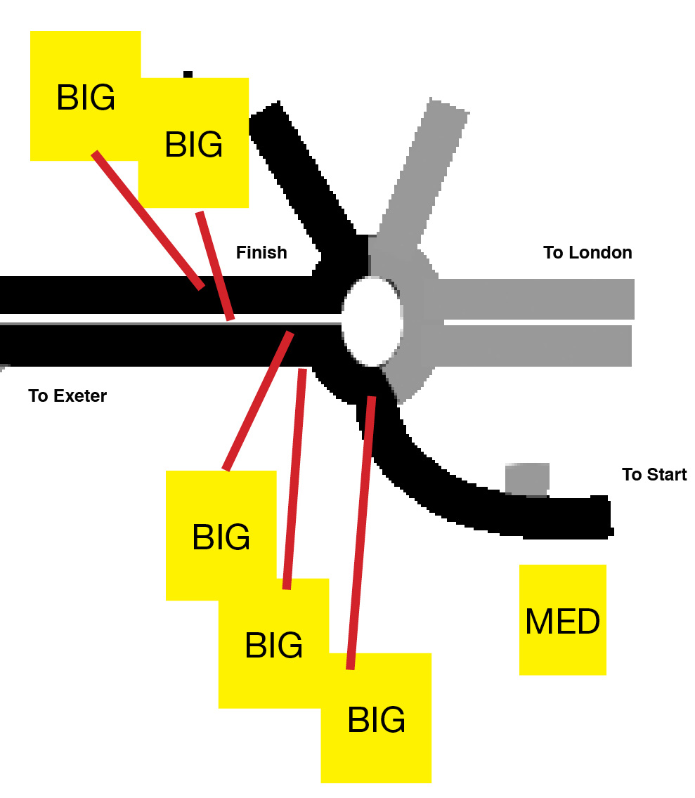 | Warning large signs as follows:  One on the triangle of grass at Podimore village exit facing traffic from East.  Two on A303 westbound at exit on rbt and Observer  Two on A303 eastbound 150 m before finish.
 | 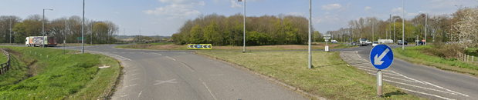
b) Start to Turn at Tintinhull, A303
5 | Join A303 at Podimore | Traffic entering from the right, riders turn left | L | Observer ; Cycle Event Warning sign on triangle (see 4)
6 | A37 slip to Yeovil off A303 | Traffic leaving A303 to join A37, riders continue straight on A303 | M | Covered by sign at Podimore See 4
7 | A37 slip from Yeovil onto A303 | Traffic joining from the left onto A303 from A37, riders continue straight on A303 | M | Cycle Event Warning sign at head of slip road
8 | Approach to turn (leaving A303)  Turn Left | Overshooting turn, no safe turning point | L | Observer
 |  | 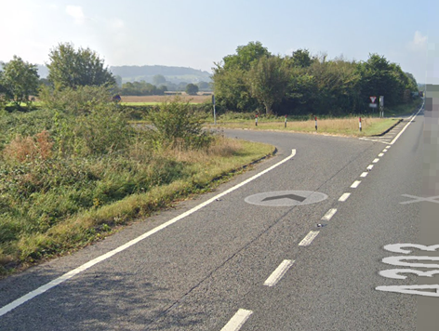
9 | Give way at T-Junction with Tintinhull / Ash road | Left turn ; Low volume of traffic approaching from right, poor visibility. | M | Cycle Event Warning sign on main road, 50 m before junction towards Tintinhull. Optional: Observer at junction to observe traffic and riders.
 | Riders must observe to right to ensure clear | 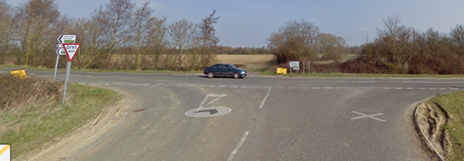
10 | Pass over flyover start to drop down.  Turn left | Adverse camber on corner | M | Note on start sheet
 |  | 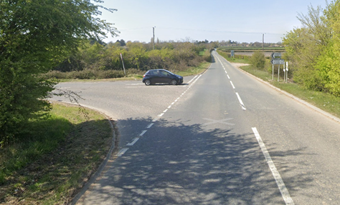
11 | Turn left to rejoin dual carriageway | No slip road, traffic approaching at high speed | M | Note on start sheet about no slip road. Two large warning sign on dual carriageway, 50 m towards Cartgate roundabout. Observer positioned on island to observe traffic and riders.
 | Riders must keep left when joining DC and observation to right is essential | 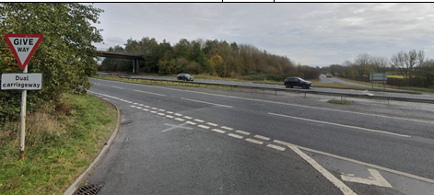
C) Tintinhull A303 to Podimore R/about to Finish
12 | Shell garage/cafe | Traffic rejoining A303 from petrol station/cafe | L | Cycle event warning sign at exit
13 | A37 slip to Yeovil off A303 | Traffic leaving A303 to join A37, riders continue straight on A303 | M | See 9
14 | A37 slip from Yeovil onto A303 | Traffic joining from the left onto A303 from A37, riders continue straight on A303 | M | Cycle Event Warning sign
15 | Finish. Before roundabout. | Riders finishing | L | See 4
16 | Return to the HQ | Riders to approach traffic lights on roundabout, if all clear take right hand lane or stay left and take Langport exit, proceed to Lytes Cary turning where they can turn and retrace back to R/about, return to the HQ | M | Instructions on Start Sheet

Footnote: Include on start sheet:
Please note: A large part of this course is a dual carriageway and if the weather is poor the visibility deteriorates quickly. The event will be delayed or cancelled if there is a danger to riders.

Course start: At the 1st drain cover west of the first gate west of the 30mph sign on the western side of Podimore village.

Course finish: on A303 approximately 400m before Podimore roundabout at traffic lights sign.

This document remains live and any changes to the items listed above or new hazards/risk that arise should be notified to the district committee at the earliest opportunity.

CYCLING TIME TRIALS IS A COMPANY LIMITED BY GUARANTEE REGISTERED IN ENGLAND No: 4413282
Registered Address: 77 ARLINGTON DRIVE, PENNINGTON, LEIGH, LANCASHIRE. WN7 3QP January 2012

