Prize list 2024

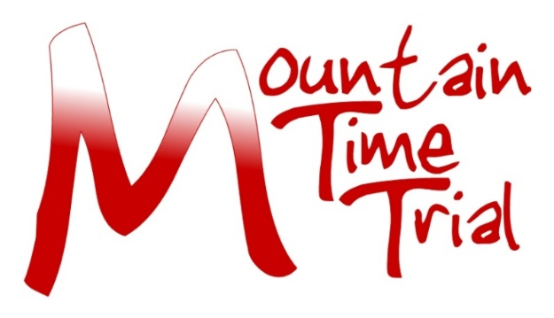

Tyneside Vagabonds CC 70th Mountain Time Trial 19th May 2024
Results & Prizes
Provisional results are likely to be available from the N&DCA Facebook page as soon as possible after the event. Official results will be on the CCT website and emailed to all competitors once formalised.
There will be a prize giving and buffet available after the event for those who wish to attend. We will also contact prize winners who are not available for the prize giving, as soon as possible once the results have been verified.
All profits from this event go to the Great North Air Ambulance;
https://www.greatnorthairambulance.co.uk.
Please let the event secretary or club treasurer (Kelly-Jo Huntley; bbbk@live.co.uk) know if you prefer to donate your prize to this worthy cause
Trophies
Fastest Time Marion Bunton Trophy
Fastest Female Dorothy Dent Trophy
Fastest Junior Ian Vaughan Trophy
Fastest Vet on Standard J.K.Marshall Trophy
Fastest Ascent of Bilsmoor (Male) Russell Thompson Trophy Fastest Ascent of Bilsmoor (Female) Ron Steele Trophy
Fastest men’s road bike Winter’s Gibbet Trophy
Fastest women’s road bike The Impromptu Trophy

Prizes
Overall winner
First £30
Second £20
Third £10
Female
First £30
Second £20
Third £10
Road bike
Open
First £30
Second £20
Third £10
Female
First £30
Second £20
Third £10
Bilsmoor Climb
Fastest open £20
Fastest female £20
Fastest Vet on AA time
First £30
Second £20
Third £10
Fastest time category (Spindata)
Cat B £20
Cat C £20
Cat D £20
Cat E £20
Thanks to our sponsors Ian and Tina Sutton.
One prize per rider, except for Ascent of Bilsmoor.
For the Road Bike Category the following rules apply;
No tri bars, wheels no deeper than 90mm and with a minimum of 12 spokes (no disc wheels). Skin suits, aero helmets and aero socks now permitted.

